# **SPECIFICATION & PROJECT MANAGEMENT (SECTION-A)**

## 1.Project Overview

The project's goal was to develop a user-friendly UI/UX for a website where visitors could publish and read blog-style entries. The website had categories, titles, and post sections that let users group their articles into categories and make it simpler for visitors to do topic-specific searches. I was an AI language model, so I didn't personally contribute to the project's creation, but I can provide an evaluation based on the details that were provided to me. The website's sleek, contemporary design, which was both aesthetically pleasing and user-friendly, was one of its significant advantages. The typefaces and color scheme were both well-chosen, which improved the user experience overall. A bigger audience may visit the website because it was optimized for both desktop and mobile devices. The application was created using a database-based user interface, allowing users to upload several categories with the post to the web application page with their own title selections and make them available for viewers to see using a contemporary UI/UX modern design.

## 1.1.Purpose

The goal of a project may be to develop a website that allows users to publish and read blog-style content with an emphasis on enhancing user experience through an easy-to-use and cutting-edge UI/UX design. To make it simpler for consumers to explore and find specific material, the website might have features like categories, titles, and post sections. In order to promote accessibility to a larger audience, the project might also attempt to optimize the website for both desktop and mobile devices. The main purpose of the website is to let the viewer became the user to access the page and can administer some part related to database such as editing post, adding new post and deleting the post. The restricted part is to control and administer the existing and the new user data.

## 1.2. Scope

The brand recognition for the website name is “Alternese”. Alter stands for the function that user and admin can operate with the project, Nese stands for everything related to the UI/UX Design withstand by web page. The scope of the website is to build a community that discusses alternative themes, encourages a sustainable lifestyle, and exchanges information and experiences in those areas.

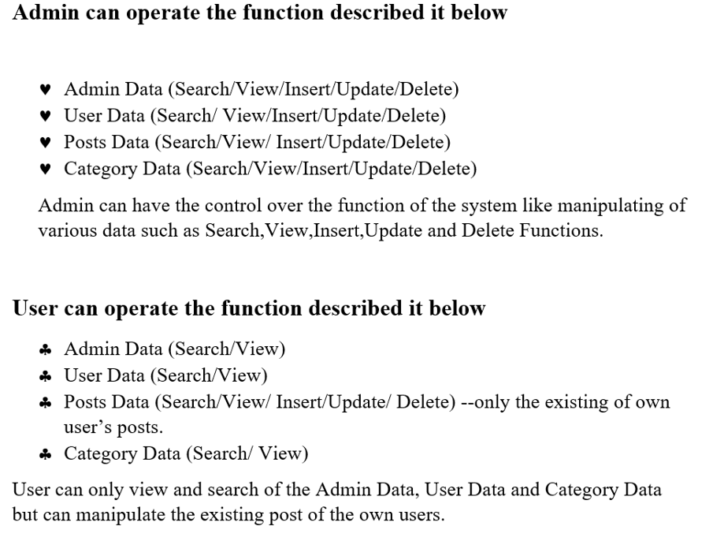

## Project Objectives:

**User**

* The Alternese website offers a platform for new users to find out more about alternative subjects connected to lifestyle, education, nature and health while interacting with a community of like-minded people.
* User acquire knowledge by viewing the beautiful post uploaded by the existing user and the system admin.
* The user may go through the website's categories to find certain information that relates to their interests.
* The user may utilize the search box to look for specific material, and the latest and most popular articles sections let users keep up with the most pertinent and recent information.
* If the user wants to view the post, he/she can click the post and can completely read all the written word related to selected topic with the user detail and the duration Information.
* If the new user wants to add post or edit post by selecting the different categories, he/she would first to became the user of this website.
* If not, the user has to follow the sign-up procedure to add a new post.
* After the procedure of signup, the user has to sign in again for the sake of High alert security and the Authentication.
* Now the user can access by adding post, deleting post, editing post and many more.

**Admin**

The Alternese website will provide administrators access to a dashboard where they may control the website's content, users, and general functionality. Only those employees who have been given permission and are in charge of upholding the website's integrity and standards.

* The system must identify the login of the admin.
* Posts and categories can be added, edited, and deleted by the admin. In order to guarantee that user-posted content complies with the rules and standards of the website, the admin can also monitor it.
* The administrator has control over user accounts, the acceptance or rejection of user-generated material, and comment moderation. Additionally, the administrator can control user rights and roles, such as limiting access to particular website sections.
* Through the use of analytics tools, the administrator may monitor the functionality and user interaction of the website. By keeping an eye on the speed and making sure it is operating effectively, the admin may also improve the website's performance.
* By putting security rules into place, the admin may control the security of the website and thwart viruses, hacking attempts, and unauthorized access.
* The admin can manage the website's design and theme by customizing the website's layout, typography, and color schemes.
* The admin can vary by assigning of the replace posts, the category and the users. The admin can make other user to became admin to manage all the functionality as describe above of the following.

Overall, the Alternese website's admin area offers the administrator the instruments required to oversee and enhance the website's content, performance, and security, making sure that it complies with the site's standards and rules.

# **1.3. Project Constraints and Risks**

Risks and restrictions related to the project might have an impact on its success. Resources, time, money, technology, and other limits may all be constraints that affect a project's viability or efficiency. Both internal and external elements, such as human mistake, technological malfunctions, environmental conditions, or legal and regulatory difficulties, might pose risks. Project managers must recognize, evaluate, and minimize potential risks and limits in order to complete the project on schedule, within budget, and with the intended level of quality. The ability of the project managers and stakeholders to be aware of potential risks and constraints and to take proactive measures to manage them effectively is particularly important in addressing the project constraints and risks.

# **1.4.Schedule and Budget Summary**

The Alternese Project requires a minimum of 20 members. The customer is a key player in the project's timeline and cost breakdown for developing a website. They give the project specifications and give their approval for the final budget and timeline. The stakeholder's job is to keep an eye on the project's development and make sure that it is completed on time and within the allocated budget. In order to make sure that activities are performed on time and within budget, the project manager is in charge of developing and overseeing the schedule and budget. The analyst examines the project specifications and assists in identifying possible hazards that could have an effect on the project's budget and schedule. The developer is in charge of designing and testing the website to make sure it adheres to the project specifications and is delivered on schedule. The tester verifies the website's functionality and checks it for defects. Together, the client, stakeholder, project manager, analyst, developer, and tester can make sure that the project is delivered on time, within budget, and to the specified quality standards. They can also make sure that the schedule and budget summary is correct.

|  |  |  |  |  |
| --- | --- | --- | --- | --- |
| Task | Initial Date | Final Date | Organizer | Budget |
| Project Planning | 15th March 2023 | 20th March 2023 |  | $16,000 |
| Requirements For the Enterprises | 20th March 2023 | 25th March 2023 |  | $50,000 |
| Design implementation and Prototyping | 25th March 2023 | 26th March 2023 |  | $3000 |
| Website Development | 26th April 2023 | 6th April 2023 |  | $50000 |
| Website Testing | 6th April 2023 | 8th April 2023 |  | $1000 |
| Implementation and Integration | 8th May 2023 | 12th May 2023 |  | $3000 |
| Operations and Management | 12th May 2023 | 16th May 2023 |  | $4500 |
|  |  |  | **Total Budget** | $127,500 |

# **2.Requirements Definition**

The following definitions are required before a website can be developed: the website's purpose and goals, its target audience, its features and functionalities, its design and layout, the content management system (CMS) to be used, its web hosting platform, its user interface and user experience (UI/UX) design, its content creation strategy, and its search engine optimization (SEO) strategy. These definitions will serve as a roadmap for creating and launching the website, ensuring that it adheres to project specifications and is delivered on time and on budget. For example, the project team members, software and hardware specifications and many more.

## Software Requirement

The website is basically the blog type posts where abundant necessity software has been used.

* To design and administer the content of the website, used a content management system (CMS) like WordPress, Joomla, or Drupal.
* To design and create the website, use a web development application programming language like HTML5, CSS, JAVASCRIPT, PHP and the database system for MYSQL and many more.
* To host the website online, use a web hosting service like Bluehost, Site Ground, or HostGator.
* Utilize a web browser, such as Microsoft Edge, Mozilla Firefox, or Google Chrome and Opera Browser to view and test the website.
* Must use code editor such as Visual Studio Code to write and edit the website code.
* To develop and alter website graphics and pictures, used an image editing program like Adobe Photoshop and Canva for the better user experience.

## Hardware Requirements

* The requirement needed to debug the system we need the high efficiency operating system and the driver related to the system.
* A portable laptop or the Monitor-desktop not less than 8GB dual Core-processor is required.
* 1920*1080 resolution is required to design and develop the website for the better UI/UX design.
* For web surfing, website testing, and online collaboration, a dependable internet connection with a minimum speed of 12 Mbps is required.
* Website papers, contracts, and invoices may be created and printed using a printer and scanner.

## Project Members

|  |  |
| --- | --- |
| Project Members | Responsibility |
| Client | The client's duties and responsibilities include outlining specific project needs, offering suggestions and approvals, creating and managing content, conducting testing and validation, and providing continuing maintenance and support. |
| Project Manager | The project manager's duties and responsibilities include managing the project's scope, timeline, and budget, coordinating the project team, ensuring effective stakeholder communication, resolving problems and risks, and ensuring that the website is successfully delivered in accordance with the specified specifications and quality standards. |
| Stakeholder | The stakeholder's role and responsibility include giving input and feedback on the project's requirements, goals, and objectives; participating in decision-making processes; reviewing and approving project deliverables; providing the necessary resources and support; and making sure that the website project is successful overall and meets their needs and expectations. |
| Analyst | The Analyst's role and responsibilities include carrying out research and analysis to comprehend user requirements, identifying and documenting project specifications, working with stakeholders to collect and clarify project requirements, and offering insightful guidance and recommendations to direct the development of the website, ensuring that it satisfies user needs and is in line with project goals. |
| Developer | Implementing the website's functionality and design is a key part of the Developer's duty and obligation. This entails writing clear and effective code, creating the necessary features, such as blog post creation, category tagging, and user interaction, making sure the website is responsive across a variety of devices, integrating the front-end with the back-end systems, handling data storage and retrieval, and carrying out extensive testing to find and fix any bugs or problems. In order to make the website functional and to ensure its creation, the developer is essential. |
| Assurance Tester | The Assurance Tester's position and duty in the pictured scenario entail thoroughly testing the web application to guarantee its usability, quality, and overall user experience. The Assurance Tester is tasked with developing test plans and test cases, carrying out different testing methodologies such functional testing, usability testing, and performance testing, finding and documenting any flaws or problems, and working with the development team to address them. They want to make that the website is functional, provides a great user experience, and complies with the standards. |

# **3.Work Breakdown Structure**

**1.0 Project Planning**

1.1Define project scope and objectives

1.2Identify project team members

1.3Develop project schedule and budget

1.4Monitor and control project progress

**2.0 User Interface (UI) Design**

2.1Conduct user research and analysis

2.2Develop wireframes and prototypes

2.3Create visual design concepts

2.4Refine design based on feedback

**3.0 User Experience (UX) Design**

3.1Define user personas and user scenarios

3.2Develop user journeys and flowcharts

3.3Conduct usability testing

3.4Analyze and refine user experience

**4.0 Blog Functionality**

4.1Define blog post categories and tags

4.2Develop blog post creation and editing functionality

4.3Create blog post search and filtering options

4.4Implement commenting and social sharing functionality

**5.0 Front-end Development**

5.1Convert design into HTML/CSS templates

5.2Develop responsive design for different screen sizes

5.3Implement UI interactions and animations

5.4Integrate blog functionality into the front-end

**6.0 Back-end Development**

6.1Set up database and data models

6.2Develop authentication and authorization functionality

6.3Implement blog post storage and retrieval

6.4Develop API endpoints for front-end integration

1. **Testing and Quality Assurance**

7.1Conduct functional testing of all features

7.2Perform user acceptance testing

7.3Identify and fix bugs and issues

7.4Ensure cross-browser compatibility and accessibility

**8.0 Deployment and Maintenance**

8.1Prepare for deployment to production server

8.2Launch the web application

8.3Monitor and maintain server and database performance

8.4Provide ongoing maintenance and support for the application.

1. **Project Management/Close Out**

9.1Monitoring and tracking project progress and performance.

9.2Managing and mitigating project risks and issues.

9.3Communicating and reporting project status to stakeholders and sponsors.

9.4Conducting project closure activities and performing a post-implementation review.

## Gantt Chart

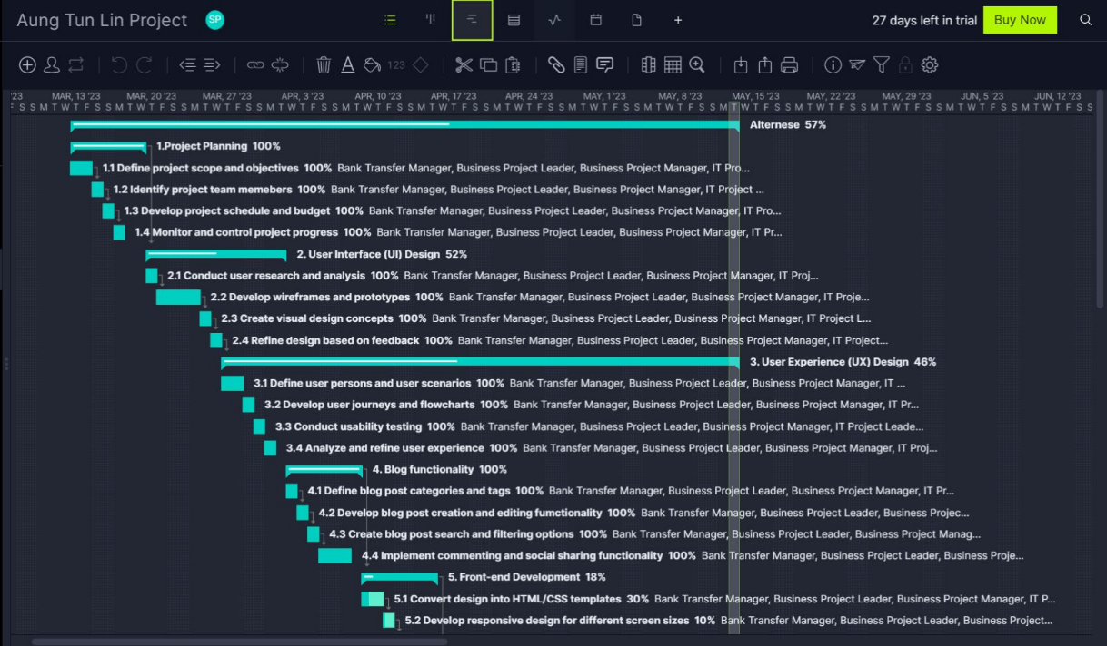

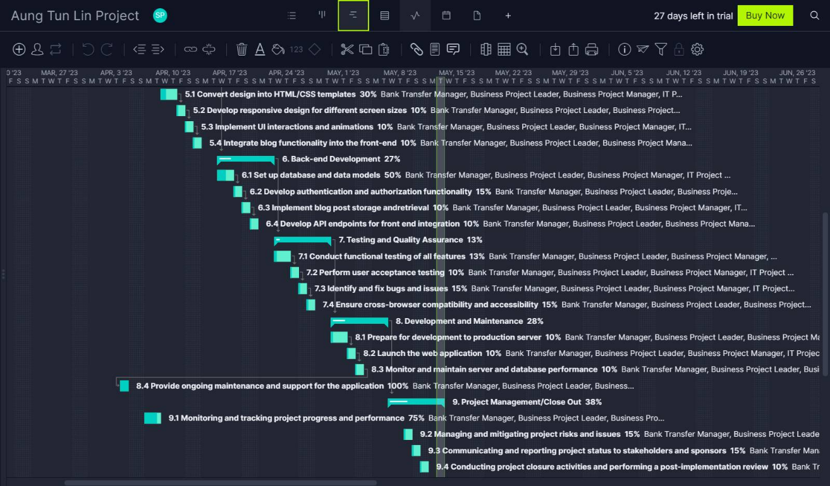

|  |  |  |
| --- | --- | --- |
|  | Names | Approximate Cost |
| System Requirement | Software Licenses | $2500 |
| Database Store Licenses | $1000 |
| Network Licenses | $500 |
| Servers Licenses | $2500 |
| Personnel (Project Management Team) | Consultants | $2000 |
| Project Manger | $2500 |
| Software Developer | $3000 |
| End Users | $1000 |
| Finical Manager | $2500 |
| Software Tester | $1000 |
| Security Team | $2000 |
| Maintenance and support | $1500 |
|  | Total | $22000 |

## **Section B (System Requirements Specification and Analysis)**

## System Requirement Specifications

### Functional Requirements

Functional requirements are a collection of guidelines that specify what the website must be able to accomplish and how it must function to satisfy the demands of its users. These specifications, which specify the operation, features, and capabilities of the website, are precise and quantifiable.

Here, functional Requirements that is essential for the Alternese UI/UX Experience

* User authentication enables users to write and manage their own blog entries by allowing them to register and log in to the website.
* Search functionality: The website should allow users to conduct keyword or other search-related searches to find specific content.
* The website has a category system that enables users to arrange blog articles according to subjects or topics.
* Navigation and menus: The website have an easy-to-use navigation structure, complete with menus and links that direct visitors to specific pages.
* In order to allow people to view the material on a range of devices, the website is responsive, which means that it can adjust to changing screen sizes and device kinds.

### Nonfunctional Requirements

Non-functional requirements are the operational or technical specifications that specify how the system should behave rather than what it should accomplish. These specifications are necessary to make sure the system lives up to the expectations of the user and describe system attributes like performance, dependability, usability, and security. Non-functional needs must be quantifiable and testable in order to be verified during the project's development and testing phases. A website's page load time, for instance, is swift enough to guarantee that users can access the site without any delays. Regardless of the device being used to view it, websites that are responsive allow people to engage with them without any issues. In order to protect user data from harmful assaults, security regulations have been put in place.

In conclusion, non-functional criteria are essential to a website project's success because they guarantee that the website not only functions as intended but also operates at its best and satisfies the users' needs in terms of usability, security, and performance.

## **UML Diagrams for Alternese Website**

### 1.1 Use Case Diagram

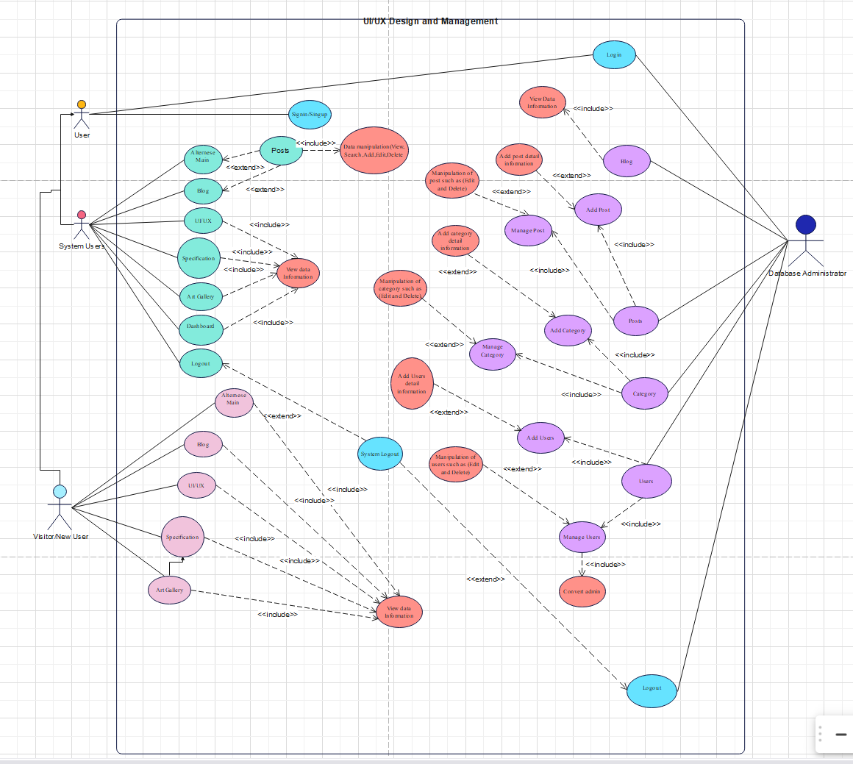

### 1.2 Class Diagram

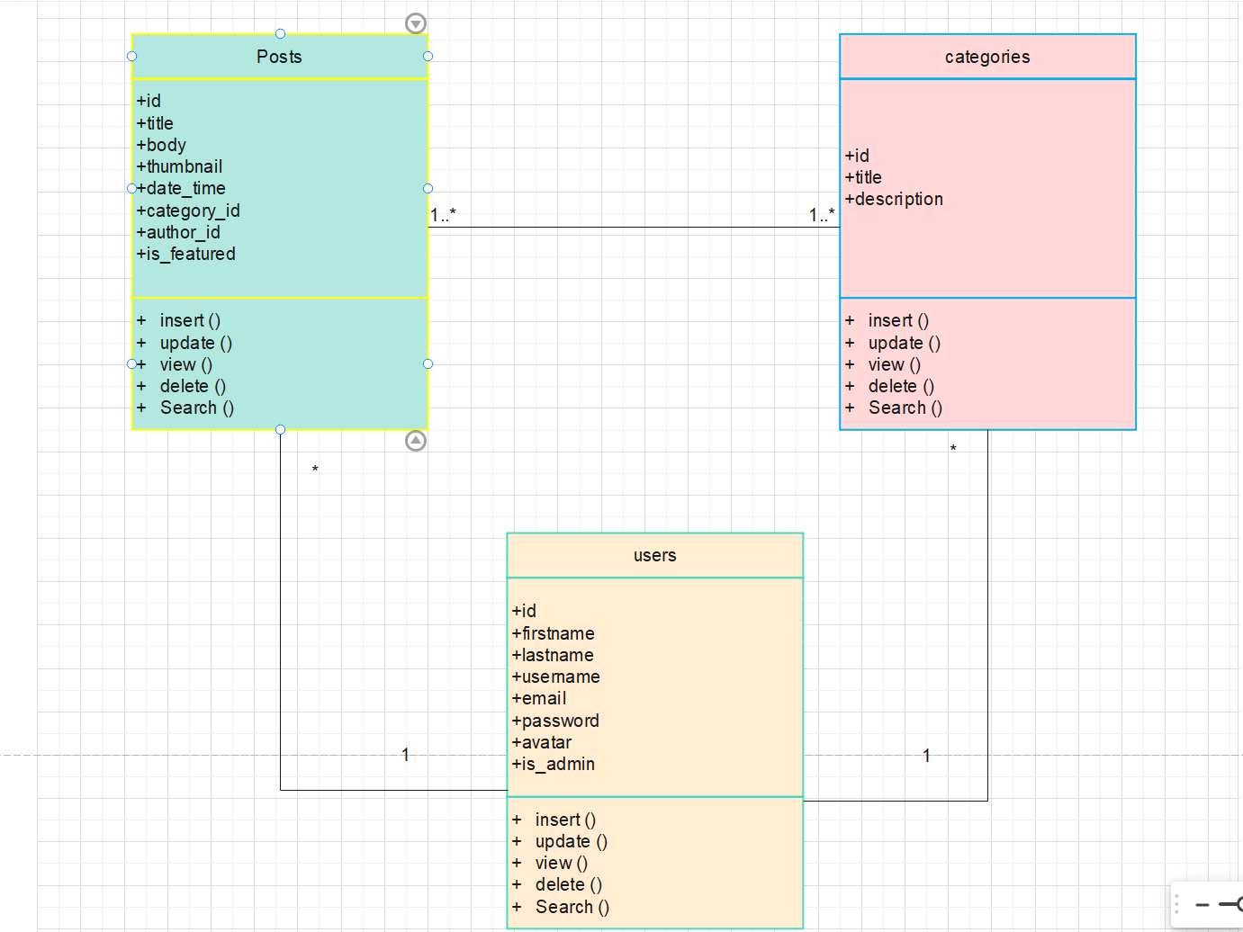

### 1.3 Sequence Diagram

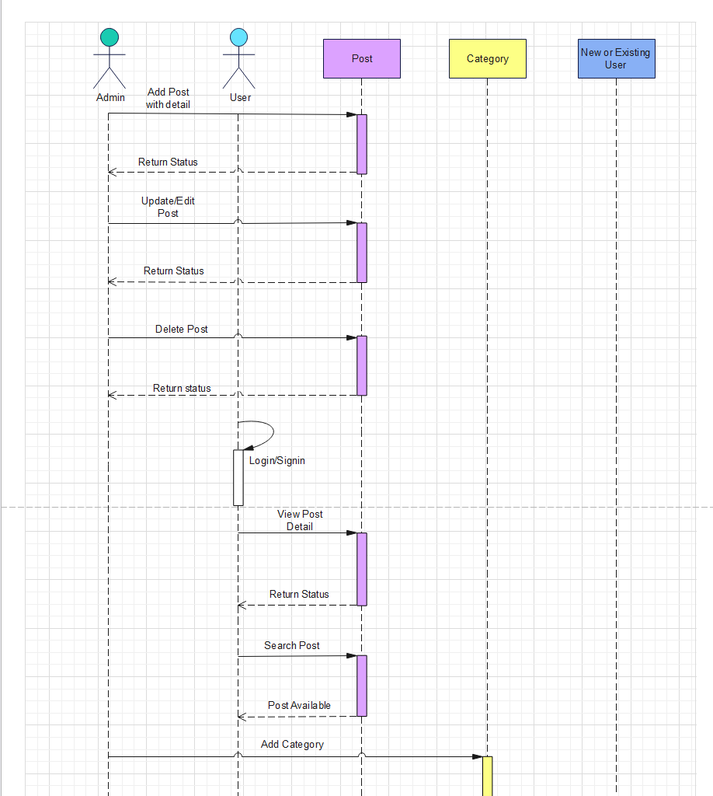

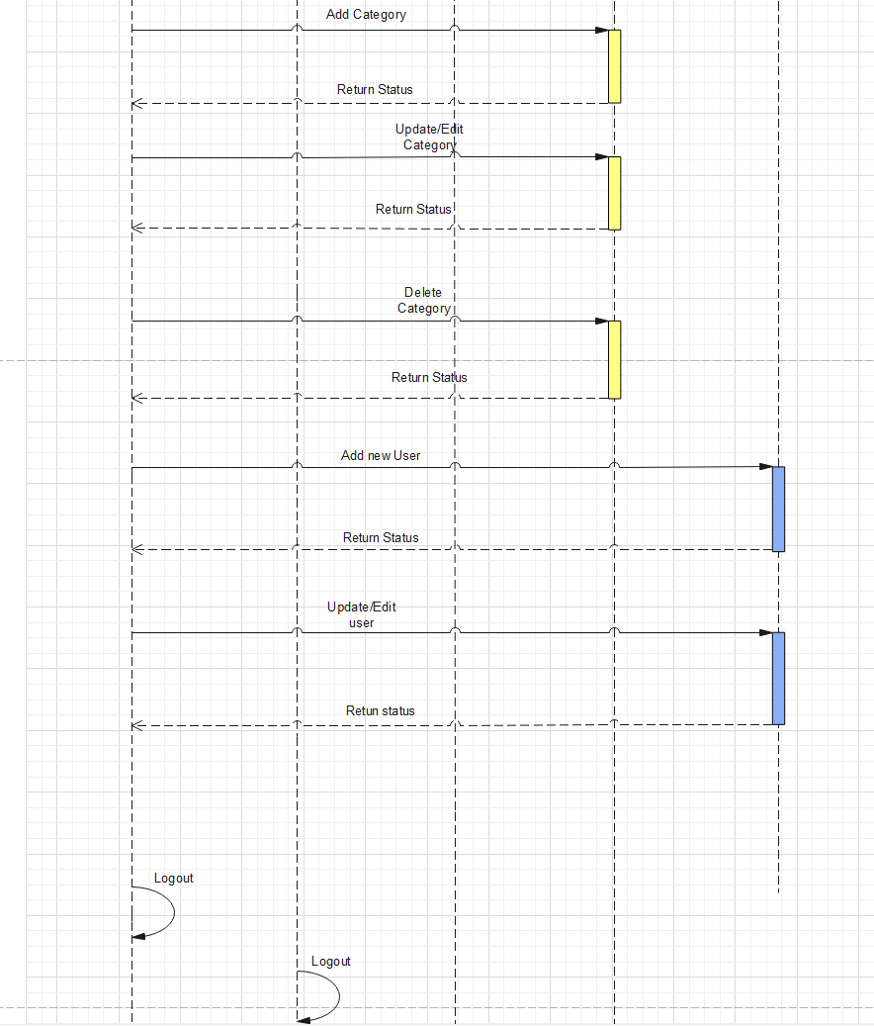

### 1.4 State Transition Diagram

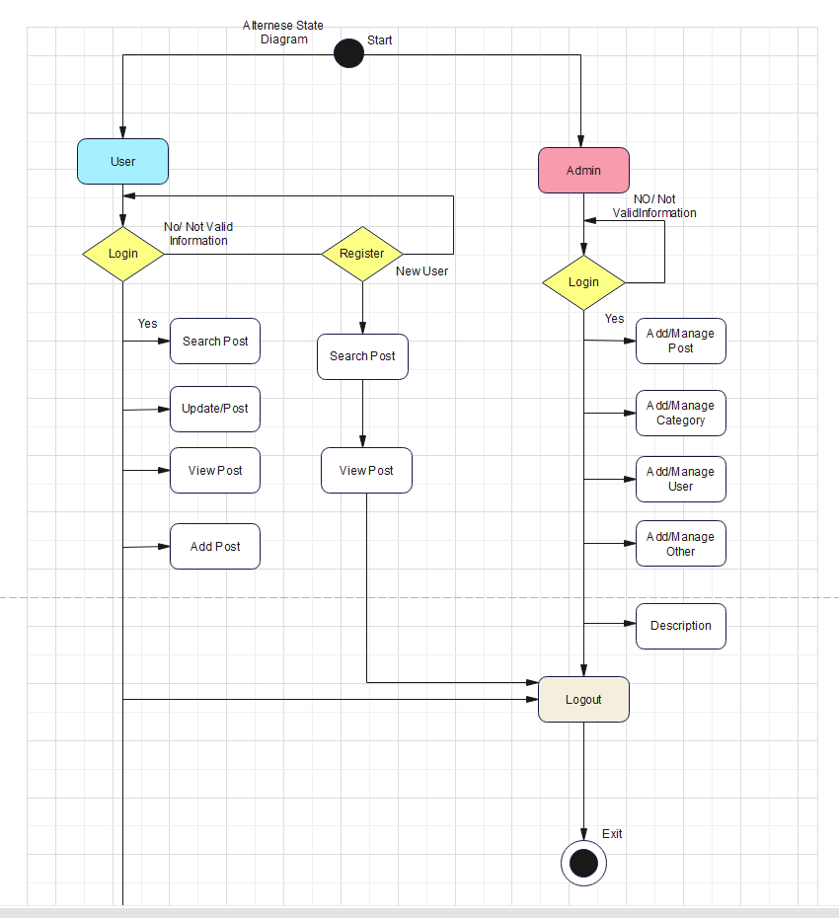

### 1.5 Activity Diagram

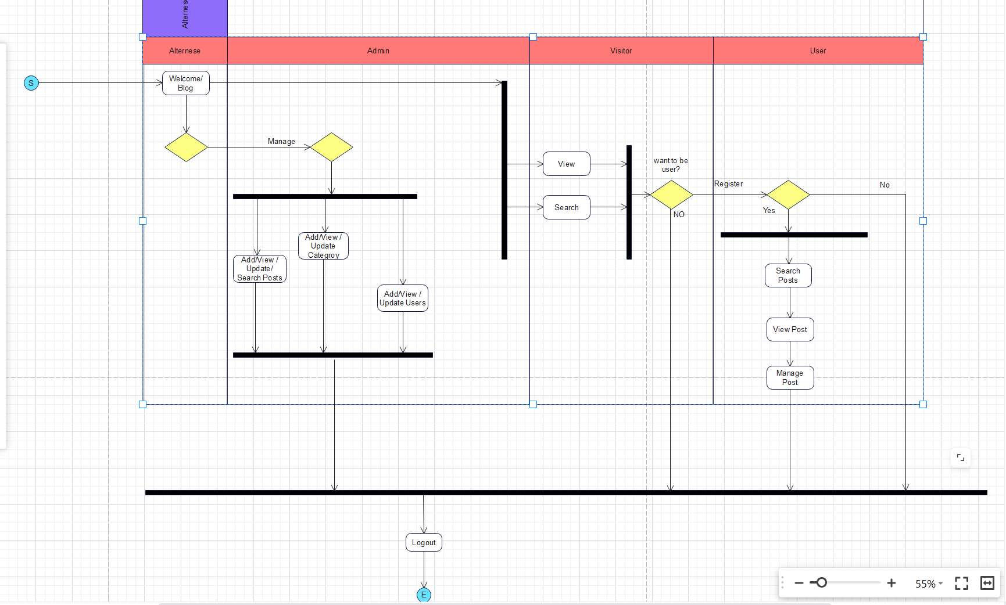

### 1.6 Entity Relationship Diagram (ERD Diagram)

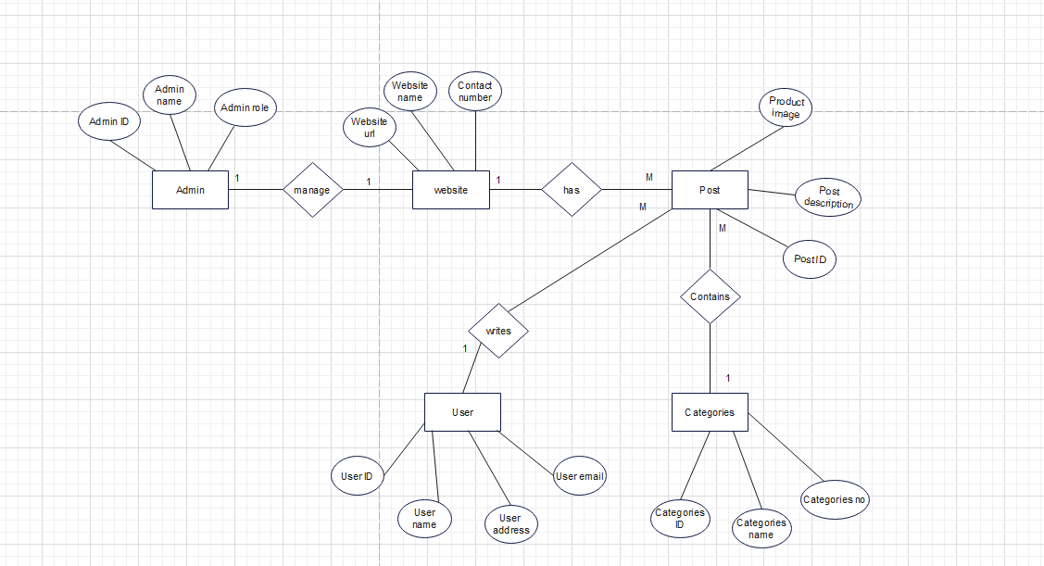

### 1.7 Process Description

|  |  |  |
| --- | --- | --- |
| Process Name | | Description |
| 1. Project Planning | 1.1Define project scope and objectives | The goal of the project is to construct and implement a web application that enables users to write and publish blog entries with various categories and headings. The program must have a user interface that is both appealing and simple to use, as well as a smooth user experience. Creating a reliable and secure database to house user information and blog entries is also included in the scope.  To develop a user-friendly online application that enables users to compose and publish blog entries with categories and titles.  To improve user experience, to offer a user-friendly and appealing UI/UX design. |
| 1.2 Identify project team members | Choosing the people or positions responsible for building and managing the website is referred to as identifying project team members. Project manager, UI/UX designer, web developer, content writer, tester, and more positions fall under this category. To guarantee that the project is finished effectively, within the allotted time limit, and within budget, it is crucial to choose the right team members. The team members should also be knowledgeable and skilled enough to contribute to the project's goals. |
| 1.3 Develop project schedule and budget | Creating a timeline and assigning resources, such as staff, equipment, and money, is required when developing a project plan and budget. The project must be divided into smaller, more manageable jobs, and the time and resources needed for each work must be estimated. Along with identifying possible risks, the project manager must create backup plans to deal with those that could have an impact on the project's budget or schedule. The project schedule and budget for a blog-style website with UI/UX design expertise might include tasks like designing the website's layout, writing the necessary code for the blog functionality, testing the website's usability, and conducting user testing to ensure the best UI/UX design. Expenses like site hosting, software licensing, and any contractual work with designers or developers would need to be covered by the budget. |
| 1.4 Monitor and control project progress | To keep the project on track, it entails monitoring its development and making necessary modifications. This entails keeping an eye on the project's tasks, money, and schedule as well as spotting any possible risks or problems and taking remedial action to keep the project on track. In the case of a web application for a blog-type website with UI/UX design, this step might involve keeping track of how the website's various features are being developed and making sure they are meeting the project's scope and objectives, keeping track of the project team's progress, and identifying any problems that might crop up throughout the development process. The project's budget and schedule may also need to be under control to guarantee that it is finished on time and within the allocated budget. |
| 2.0 User Interface (UI) Design | 2.1 Conduct user research and analysis | Conducting user research and analysis is a crucial stage in creating a successful UI/UX for a web application that functions like a blog. Through a variety of research techniques, including surveys, interviews, and analytics, it entails discovering the target audience's wants, preferences, and pain points. After being studied, the data is utilized to develop user personas, user journeys, and wireframes. This makes it easier to make sure that the web application's design is user-centered and satisfies the target market's demands and expectations. |
| * 1. Develop wireframes and prototypes | A visual depiction of the website's layout, including the positioning of various categories, post titles, and content on the page, would be created as part of the UI/UX design, wireframe development, and prototyping processes. In order to make sure that readers can easily use and navigate the website, the wireframes and prototypes would also assist test and improve the user experience design. During this stage, wireframes and prototypes may be produced using design software like Sketch, Figma, or Adobe XD. |
| * 1. Create visual design concepts | This stage involves developing the website's visual identity, which will include color schemes, typography, and graphics. The target audience, brand image, and project goals should all be reflected in the design concepts. The visual design should match the wireframes and prototypes created in the earlier stage, and it is crucial to put the user's experience at the center of all design choices. The design of the website must be beautiful and engaging in order to draw people in and keep them there. |
| * 1. Refine design based on feedback | These comments may originate from a variety of sources, including user testing, polls, or feedback forms. Based on this feedback, the design team will alter the visual design and user interface as needed to improve the user experience and make sure the website achieves its goals. Until the desired design is attained, this process of improving the design may need several iterations. The ultimate aim of improving the design in response to user input is to provide a website that is user-friendly, aesthetically pleasing, and caters to the demands of the target audience. |
| 1. User Experience (UX) Design | 3.1Define user personas and user scenarios | The target audience's needs, goals, habits, and pain points are all identified at this phase of the project by the project team. The fictitious characters known as "user personas" were developed to reflect the usual users of an online service. The traits, objectives, and requirements of the target audience are represented by these personas, which were developed using research data. On the other hand, user scenarios are made-up tales that illustrate how a user may utilize a web application to accomplish their objectives. These scenarios are employed to pinpoint user experience problems and areas for development. |
| * 1. Develop user journeys and flowcharts | User journeys show the series of actions a user takes on a website to achieve a certain objective, such writing a new post or looking for a category. Flowcharts show the user's actions and how the system reacts to those actions. They aid website designers in laying out the logical interaction and flow of information between various pages or parts. In order to make sure that the website's navigation is simple and easy to use, as well as that the user can easily achieve their goals, it is vital to develop user journeys and flowcharts. |
| * 1. Conduct usability testing | This includes creating test cases and scenarios, choosing testers who match the user personas, and facilitating the testing process. The feedback gathered is then analyzed and used to improve the overall user experience of the application. In the context of a blog-type web application with category, title, and post features, usability testing may involve tasks such as testing the navigation menu, testing the search function, and evaluating the ease of creating and editing posts. |
| * 1. Analyze and refine user experience | To make sure it satisfies the requirements and expectations of the user, this entails examining the website's usability, accessibility, visual design, and content. Updates to the website's design, navigation, search capabilities, content organization, and other user-experience-related components may be made as part of the research and improvement process. The ultimate aim is to guarantee that the website offers a satisfying user experience that motivates visitors to interact with the content and return to the site in the future. |
| 4.0 Blog Functionality | * 1. Define blog post categories and tags | Tags are particular words or phrases that characterize the substance of the article, whereas categories are general subjects that blog entries can be categorized under. This improves search engine ranking and makes it easier for people to locate relevant postings on a certain subject. For instance, categories can be "Technology," "Fashion," or "Travel," whereas tags might be "Artificial Intelligence," "Machine Learning," "Programming Languages," etc. for a technical article. |
| * 1. Develop blog post creation and editing functionality | This can involve features like a text editor, the capacity to insert pictures or videos, formatting choices (bold, italic, bullet points, etc.), and the capacity to save drafts and submit posts.  Additional features that you might wish to add include the option to allow comments on posts as well as the capability to schedule posts for publication in the future. To make sure the intended audience can use it easily and intuitively, this functionality should be developed in accordance with the overall user experience design. |
| * 1. Create blog post search and filtering options | This may be done by implementing filters and search capabilities into the layout of your website's blog area. Users should be able to use the search capability to look for certain keywords in the blog post titles and content, and users should be able to utilize the filters to limit the results of their searches based on categories, tags, dates, and other pertinent criteria. This function can improve user experience and make it easier for users to discover the blog content they are looking for. |
| * 1. Implement commenting and social sharing functionality | This would involve adding features that allow users to comment on blog posts and share them on various social media platforms. The commenting functionality could include options for users to reply to other comments, upvote or downvote comments, and flag inappropriate comments. The social sharing functionality could allow users to share blog posts on social media platforms such as Facebook, Twitter, Instagram, and LinkedIn. This would require integration with the respective APIs of these platforms. The UI/UX design should also consider the placement and visibility of these functionalities to ensure that they are easily accessible and intuitive for users. |
| 1. Front-end Development | 5.1 Convert design into HTML/CSS templates | In order to achieve this, the design must be disassembled into its component pieces, with code templates being created for each one. The templates must to be responsive, meaning they should adjust to various screen sizes and gadgets. Following the creation of the templates, the blog site's real web pages, which display the blog entries, categories, tags, and other pertinent data, will be developed. |
| 5.2 Develop responsive design for different screen sizes | When creating a responsive design, the HTML/CSS templates and UI/UX design will be modified and optimized to accommodate a variety of devices with varied screen sizes, such as smartphones, tablets, laptops, and desktops. Whatever device consumers use to browse your website with, they will get a consistent and optimal experience thanks to this. |
| * 1. Implement UI interactions and animations | To make the user experience more interesting and natural, this might involve adding hover effects, click animations, page transitions, and other visual feedback. The intention is to give the app a more dynamic, responsive feel that will help maintain users' attention and engagement. |
| * 1. Integrate blog functionality into the front-end | The process of integrating blog features into the user interface of a web application include enhancing the user interface with the appropriate code and features to give users access to and interaction with blog features including creating and editing blog posts, leaving comments, searching, and filtering. This entails creating the required pages, templates, and user interface components as well as including the essential back-end functions, such database queries and API calls. The aim is to produce a smooth user experience that enables users to simply access and utilize the blog features without any technological challenges or misunderstanding. |
| 1. Back-end Development | 6.1 Set up database and data models | It describes the procedure for creating and putting into use the database structure and data models that will be used to store and arrange the data for the blog application. This entails defining the different entities and connections existing in the system and developing tables, columns, and relationships to represent them in a useful and effective manner. The process also entails deciding how the data will be retrieved and stored, including the use of indexes and other speed optimization methods. Any web application must go through this crucial stage since it creates the framework for all subsequent functionality. This part of the development process won't be visible to the user, but it's crucial to make that the blog application functions well and can manage high volumes of data and traffic. |
| * 1. Develop authentication and authorization functionality | It refers to the implementation of a system that enables users to set up accounts, log in, access restricted material, or carry out certain tasks depending on their role or permissions. This can entail developing a registration and login process for a blog online application as well as implementing several levels of user access, including admin, editor, and normal user. It guarantees user data protection and privacy and gives users control over who may make specific website-related decisions, such posting, editing, or deleting comments or blog entries. According to the user's point of view, this capability enables them to have a tailored experience on the website, access their profile and preferences, and engage with the information in various ways depending on their role. |
| * 1. Implement blog post storage and retrieval | It refers to the creation of the functionality that enables users to write, save, and retrieve blog articles. This include setting up a database to hold the post data, defining data models to reflect the post structure, and writing the code that enables users to create new posts, update existing ones, and read posts. The provision of this capability is crucial for the blog's fundamental operation since it allows users to generate and post material on the website. |
| * 1. Develop API endpoints for front-end integration | It refers to the creation of the web application's back-end features that will enable server communication between the front-end (UI) and the application. This may involve developing API endpoints for accessing and submitting blog posts, categories, and tags, as well as including search and filtering capability in the case of a blog-type post with categories, a title, and a post. The front-end of the web application will make use of these API endpoints to obtain and display blog entries as well as to manage user interactions with the blog, such as leaving comments or sharing content on social media. This is an essential step in the development process as it guarantees proper communication between the front-end and back-end of the web application, giving a smooth user experience. |
| 7.0 Testing and Quality Assurance | * 1. Conduct functional testing of all features | In order to do this, testing needs to be done for all the various functionalities, including developing API endpoints for front-end integration, implementing authentication and authorization functionality, creating and editing blog posts, categorizing and tagging them, implementing commenting and social sharing functionality, setting up databases and data models, implementing blog post storage and retrieval, and more. Before deploying the application, faults and errors are often found and fixed throughout the testing phase by using a predetermined set of test cases and scenarios. The web application's ultimate objective is to guarantee that it is completely functioning and offers a seamless user experience. |
| 7.2 Perform user acceptance testing | When a web application is being tested for user approval, a set of users are invited to participate and share their opinions. Testing is carried out to make sure that the software is functional, user-friendly, and satisfies users' demands. Users will carry out a variety of actions during this phase to test the functioning of the application, including writing and modifying posts, searching for and filtering posts, as well as commenting on and sharing posts. Prior to the app's distribution to the general public, the users' input on their interactions with the app will be utilized to make any required modifications. |
| * 1. Identify and fix bugs and issues | The term "identify and fix bugs and issues" refers to the process of locating and fixing any technical flaws or mistakes that could arise during development, testing, or after the web application has been released. Debugging programming, resolving functionality problems, and dealing with potential compatibility problems are some examples of this. It is crucial to take this stage in order to make sure the application is reliable and usable for people to use and appreciate. |
| 7.4 Ensure cross-browser compatibility and accessibility | In order to find any compatibility issues and make the required modifications, this requires testing the application across several browsers and gadgets. The goal of accessibility is to make an application accessible to all users, including those with impairments. This could entail adding functions like keyboard navigation, high contrast settings, and screen readers. |
| 1. Deployment and Maintenance | 8.1 Prepare for deployment to production server | The term "prepare for deployment to production server" refers to the process of getting the web application ready to be put on a live server where it may be viewed by people. The responsibilities involved in this procedure include setting up databases, establishing server settings, improving performance, and assuring security. Additionally, it entails developing a deployment strategy and getting all the files and configurations ready to deploy the application to the production server. This stage is crucial to ensuring that the application functions without any problems in a live environment and that users can access it without any problems. |
| 8.2 Launch the web application | This entails installing the program on a production server and making sure that a public IP address or domain name can access it. Once the application has been started, users may use a web browser or mobile device to access the blog posts, categories, and tags and interact with the UI/UX design to read, search for, and comment on the blog articles. The web application development process ends with the launch phase, which marks the beginning of continuing maintenance and upgrades to make sure the program stays functional and pertinent to user demands. |
| * 1. Monitor and maintain server and database performance | "Monitor and maintain server and database performance" refers to the continuing activity of keeping the server and database operating efficiently after the online application has been deployed. This comprises keeping an eye on the server and database to make sure they are operating properly, tweaking server and database configurations to optimize performance, and spotting and resolving any potential problems. In order to provide consumers with a great user experience, the web application must function at its peak performance. |
| * 1. Provide ongoing maintenance and support for the application. | This might involve activities like frequently upgrading the application's plugins and software, diagnosing any difficulties that may occur, and offering assistance to users who need it. The performance and user experience of the application may also be improved as part of continuing maintenance and support based on analytics and user input. |
| * 1. Project Management/Close Out | 9.1 Monitoring and tracking project progress and performance. | The term "monitoring and tracking project progress and performance" describes the procedure of monitoring the project's status, milestones, and deliverables throughout the development lifecycle. This entails frequently evaluating the project's performance in comparison to set goals, spotting possible obstacles or problems that might hinder its success, and making modifications as necessary to keep the project on course.  Monitoring and tracking project progress and performance could involve routinely reviewing development timelines, making sure that all features and functionality are being implemented as planned, and spotting any potential problems or bugs that could negatively affect the user experience for a web application that is related to blog posts with categories, titles, and posts.  It could also entail monitoring user interaction with the program, such as page visits, click-through rates, and user reviews, in order to spot potential areas for development that would improve the user experience and encourage more involvement.  Overall, tracking and monitoring project progress and performance is crucial to making sure that the web application is successfully constructed and released and that on-going enhancements are made to maintain the program's high performance over time. |
| * 1. Managing and mitigating project risks and issues. | Managing and reducing project risks and issues entails spotting possible problems and dangers that could emerge during the creation of the web application and putting preventative or mitigating measures in place. This include assessing the risks and issues' possible effects, creating backup plans to deal with them, and informing stakeholders of the project's progress and any looming problems. By doing this, it is guaranteed that the development process will go as planned and that any problems or risks will be quickly resolved to reduce their negative effects on the finished product. This might entail identifying possible security concerns, including unauthorized access to user data, and putting precautions in place to prevent them in the context of a blog-style post online application. To make sure that the program can support an increasing number of users and blog posts, it may also require resolving concerns with the scalability of the application. |
| * 1. Communicating and reporting project status to stakeholders and sponsors. | To make sure that everyone is on the same page and aware of the project's progress, difficulties, and dangers, communicating and reporting the project status to stakeholders and sponsors is a crucial component of project management. Stakeholders may also provide opinions and make choices that will help the project move in the right direction. |
| * 1. Conducting project closure activities and performing a post-implementation review. | "Conducting project closure activities and performing a post-implementation review" describes the formal process of ending a project and evaluating its effectiveness and lessons gained. This includes checking that all project deliverables have been finished, archiving project materials, holding a final project review with stakeholders, and determining if the project was successful in meeting its goals. The project's performance is examined, along with what worked and what didn't, and suggestions for improvement are made for future endeavors. This assignment would entail looking at the development and deployment procedures for the web application in the context of blog postings, evaluating its functionality and usability, getting user feedback, and finding areas that may be improved in subsequent iterations. |

### 1.8 Data Dictionaries

### Posts Table

|  |  |  |  |  |  |
| --- | --- | --- | --- | --- | --- |
| Data Name/Field Name | Table | Data Type | Field Size | Constraint | Description |
| id | Posts Table | int | 11 | Primary Key | Post Id, auto generated |
| title | Posts Table | varchar | 255 | No null | Tile of the Post |
| body | Posts Table | text | - | No null | Content of the post |
| thumbnail | Posts Table | varchar | 255 | No null | The picture/video/file for the post |
| date_time | Posts Table | timestamp | - | No null | The duration of the post upload and update |
| Category_id | Posts Table | int | 11 | Yes Null | The posts belong to which category |
| Author_id | Posts Table | int | 11 | Foreign Key | The user and the admin who posted the post |
| is_featured | Posts Table | tinyint | 1 | Foreign Key | The post that is featured by the user and the admin |

### Normalization

|  |  |  |  |  |  |  |  |
| --- | --- | --- | --- | --- | --- | --- | --- |
| id | title | body | thumbnail | date_time | Category_id | Author_id | is_featured |
| 4 | excuse me this is my edit post | For as long as humanity has existed, art has been…. | 1681900485mu.jpg | 2023-04-17 16:44:10 | 2 | 3 | 0 |
| 7 | Hello this is the AI File | Lorem Ipsum is simply dummy text of the printing ... | 1681831337e2.jpg | 2023-04-18 21:41:45 | 4 | 6 | 1 |
| 8 | This is the Wild Life Photo | Contrary to popular belief, Lorem Ipsum is not sim... | 1681983510nature852.png | 2023-04-19 16:59:30 | 3 | 6 | 1 |

### Categories Table

|  |  |  |  |  |  |
| --- | --- | --- | --- | --- | --- |
| Data Name/Field Name | Table | Data Type | Field Size | Constraint | Description |
| id | Categories Table | int | 11 | Primary Key, Auto Increment | This is the categories id with the auto generated |
| title | Categories Table | varchar | 50 | NO Null | This the title id/name for the category |
| Description | Categories Table | text | -- | No Null | The Description is the content of the post posted by user. |

### Normalization

|  |  |  |
| --- | --- | --- |
| id | title | Description |
| 1 | Foods | Food is one of the most essential necessities to my life. |
| 2 | Animals | This is the section of Animals. |
| 3 | Art | This is an Art studio. |
| 4 | Science and Technology | This is the description of science and technology |
| 5 | Uncategorized | This is the description of uncategorized categories |
| 6 | Wildlife | This is the description of Wildlife... |

### Users Table

|  |  |  |  |  |  |
| --- | --- | --- | --- | --- | --- |
| Data Name/Data Field | Table | Data Type | Max Field Size | Constraints | Description |
| id | Users | Int | 11 | Primary Key | User ID, auto Generated |
| firstname | Users | varchar | 50 | No Null | The first name is required to sign up the form |
| Lastname | Users | varchar | 50 | No Null | Also, the last name is for the signup page |
| Username | Users | varchar | 50 | No Null | The username is need to sign in and login back to be part of the system |
| Email | Users | varchar | 100 | No Null | Email Validation is also required to fill in the signup form. |
| password | Users | varchar | 255 | No Null | Password is required for users’ security. |
| avatar | Users | varchar | 255 | No Null | Avatar is an image that is used to display the personality of the user. |
| is_admin | Users | tinyint | 1 | No Null | The user can be admin if requested to the system administrator. |

### Normalization

|  |  |  |  |  |  |  |  |
| --- | --- | --- | --- | --- | --- | --- | --- |
| Id | firstname | lastname | username | email | password | Avatar | is_admin |
| 1 | Aung Tun | Lin | DIAN | Gerard@gmail.com | $2y$10$0vgtGvX.9cVmH  cr./8Ociu/fc PZR  9m2BL4DeEb5  SdrT2QBE9nIlbW | 1681549104icon.png | 0 |
| 3 | Selena | Gomez | Selgo | Gomezsel34@gmail.com | $2y$10$dZ3urPhx8X  2O1MCoR0  SQvOKkaydxTnGB15l  rH8NiRUQbzyYC5gEAa | 1681641146download.jpg | 1 |
| 6 | Sing | is | sing | Sing45@gmail.com | $2y$10$o2aLpsQtxw7  h6FGMnxwG5uh  WcU3r.hYC0LZY3dR  Czi2OoG8RSpZEm | 1681830478wizard.png | 0 |
| 7 | Su | Hlaing | Teacher Su | hlaing@gmail.com | $2y$10$o2aLpsQtxw7h6  FGMnxw  G5uhWcU3r.hYC0LZY3dRC  zi2OoG8RSpZEm | 1681983661girl.jpg | 0 |

# **Section C**

## **1.System Design**

### **Database Design**

#### DB Relationship

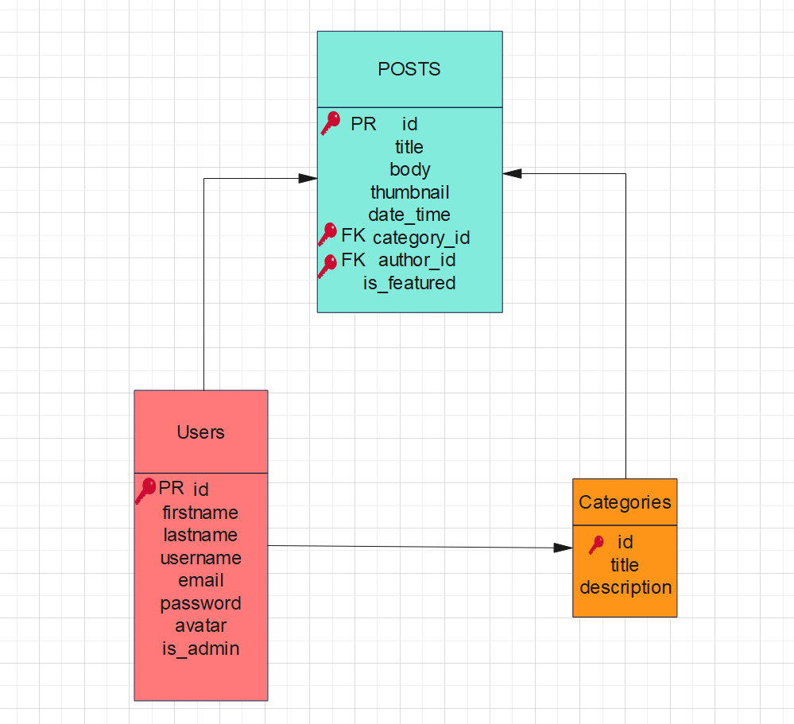

## **Section C Database Design**

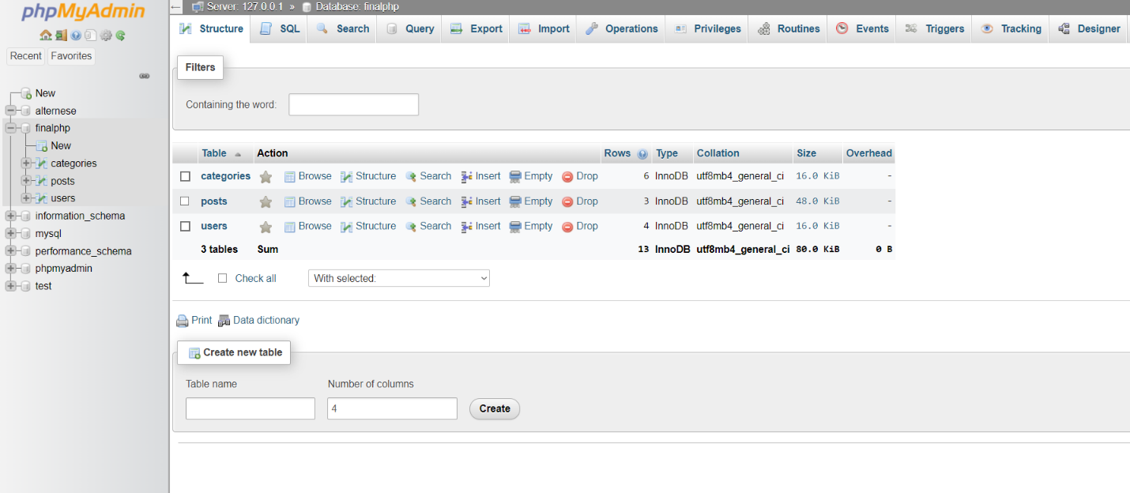

### Posts Table

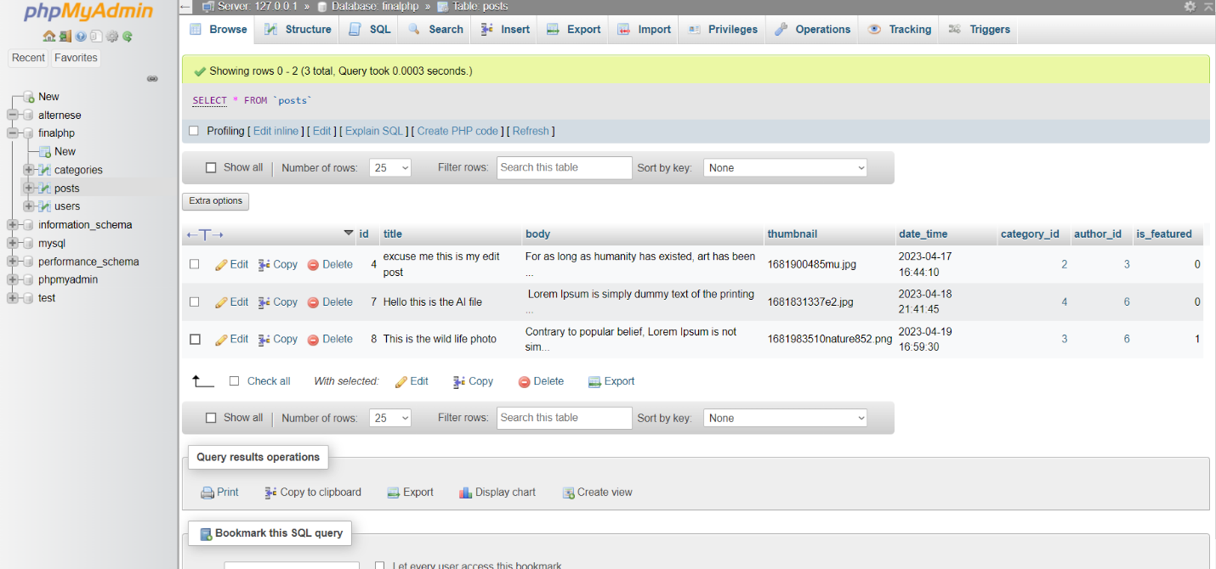

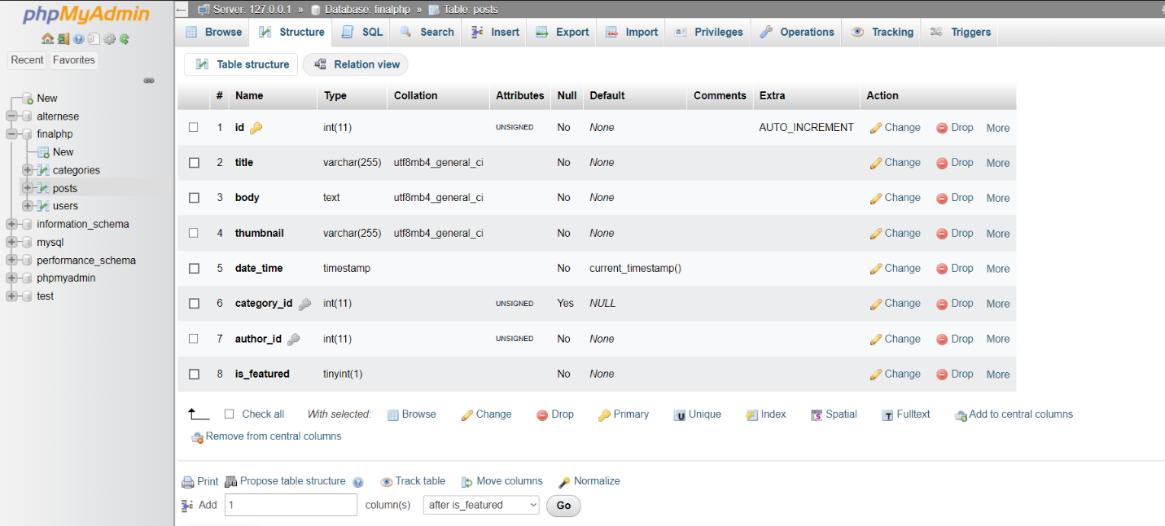

### Categories Table

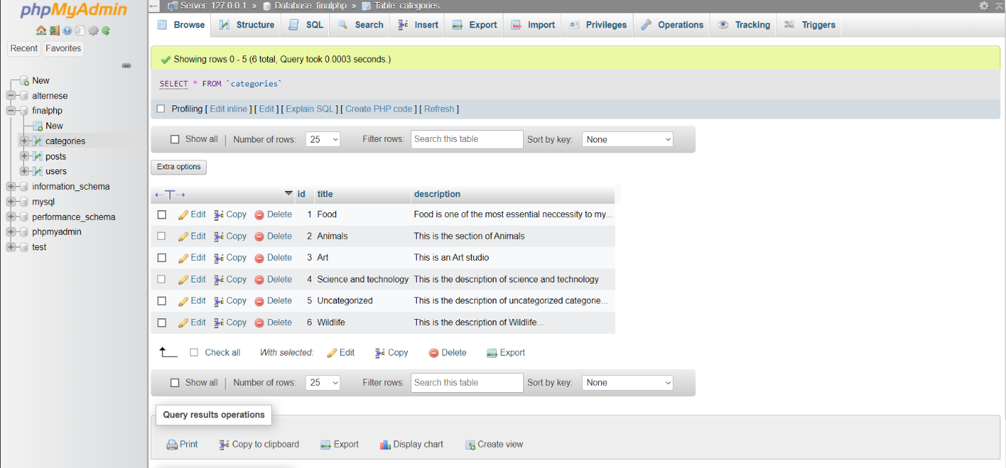

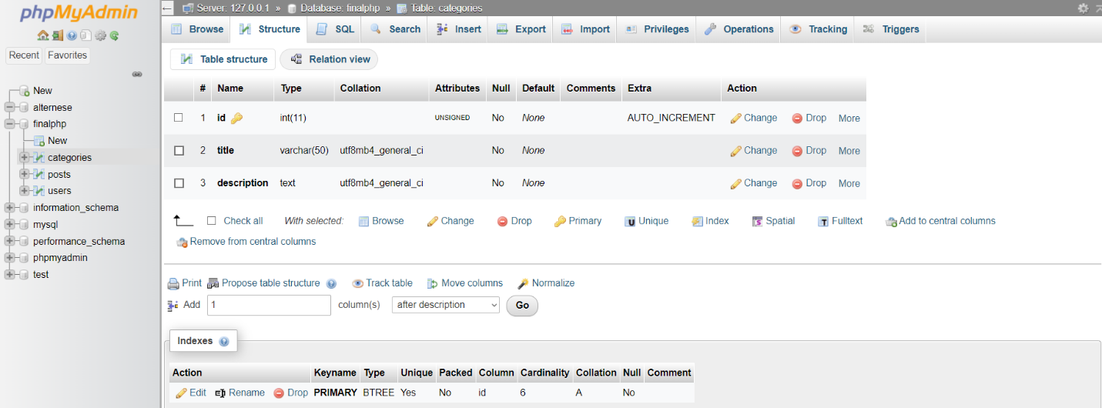

### User’s Table

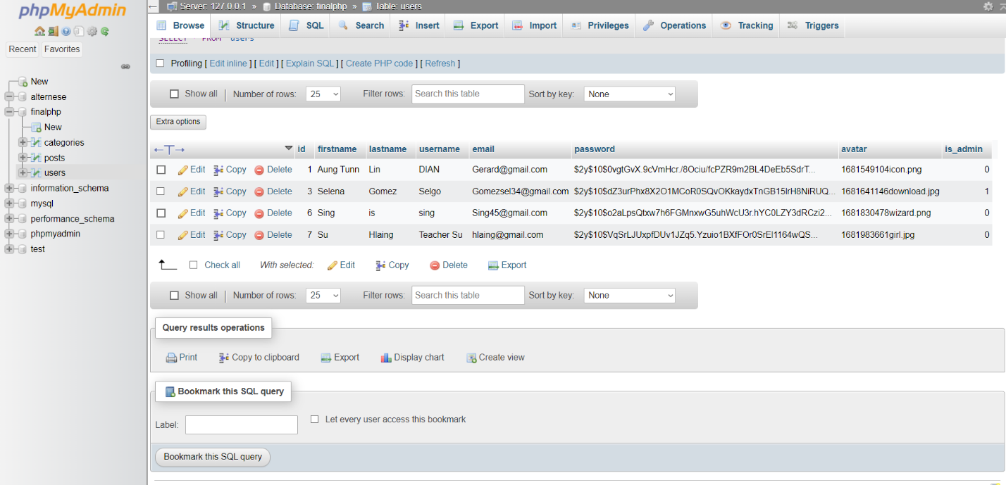

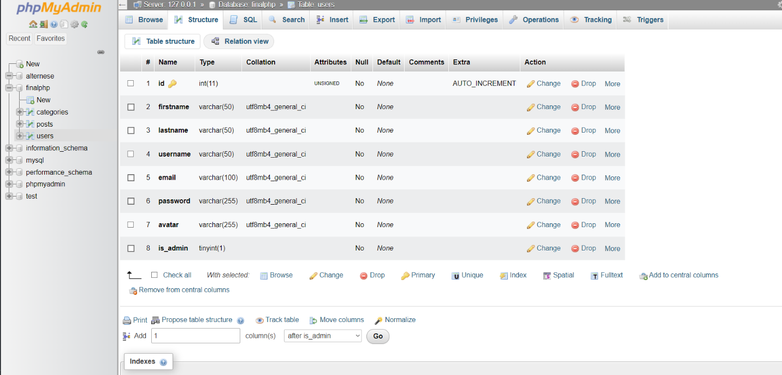

### Hierarchy Chart

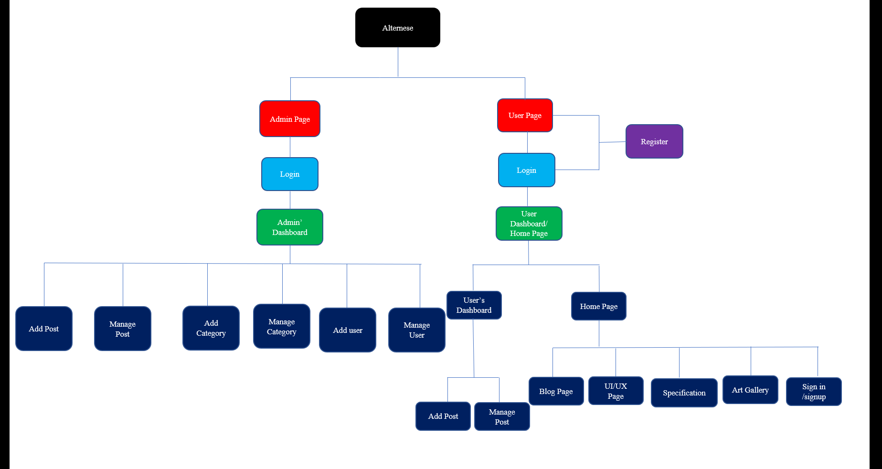

### Mini Specification

#### **User**

**Registration**-The Visitor can become the user and the admin after completing of registration

**Login**-After the Registration the user has to login back to access this page. Admin also has to login to access the Dashboard

**Home Page**-It is the first impression of the webpage when the visitor surf to it.

**User’s Dashboard**-The Dashboard of user is to manipulate user’s post.

**Add post**- Users Can Add a new post to the blog page.

**Manage Post**-Users Can Manage the existing post such as editing and deleting of the post

**Blog Page-**The main blog page is to get the knowledge from the post with the body as a content.

**UI/UX page**- This Page represent the motion of the art for the user to experience those art.

**Specification-** This Page contain of UI/UX Page with the more specification.

**Art Gallery-** This an Art Gallery Page where the random photo is rotating 360 degrees.

#### **Admin**

**Login**- The admin can log into the system for the sign in form.

**Admin’s Dashboard**- The admin Dashboard is to manipulate the Data of the Users and the admin.

**Add Post**- The admin can Add Post of his own to the web page.

**Manage Post**- The admin can manage the post of the admin and the users by updating and deleting.

**Add Category**- The administrator can add the different Category of the different users.

**Manage Category-** The admin can Manage the Category of the different users by editing and deleting.

**Add User-**Admin can add new user easily.

**Manage user-** Admin can manage the users by giving the authority of the Admin to manipulate the data of the users.

# **1.4 Interface Design**

## Design Plan

### User Interface / Visitor Interface

#### Home Page

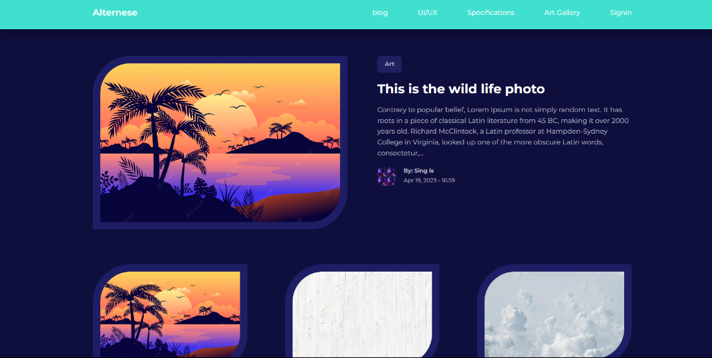

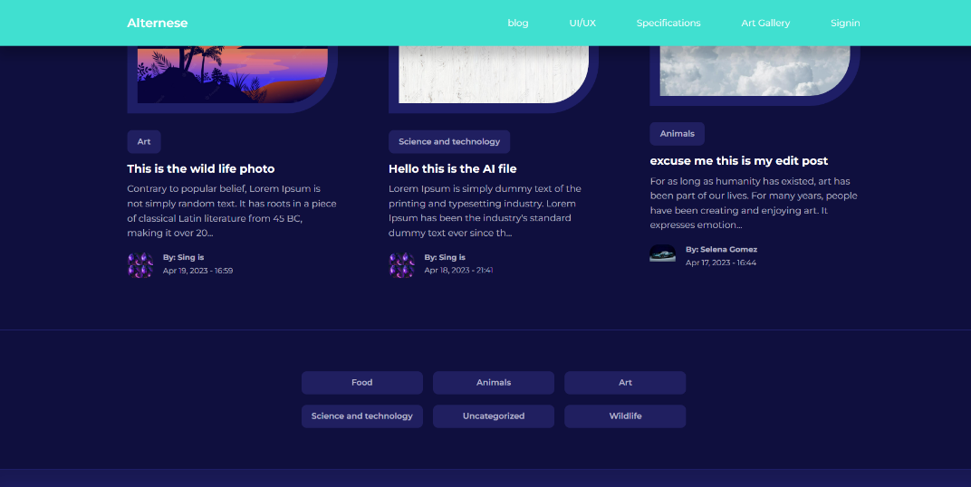

#### Blog Page

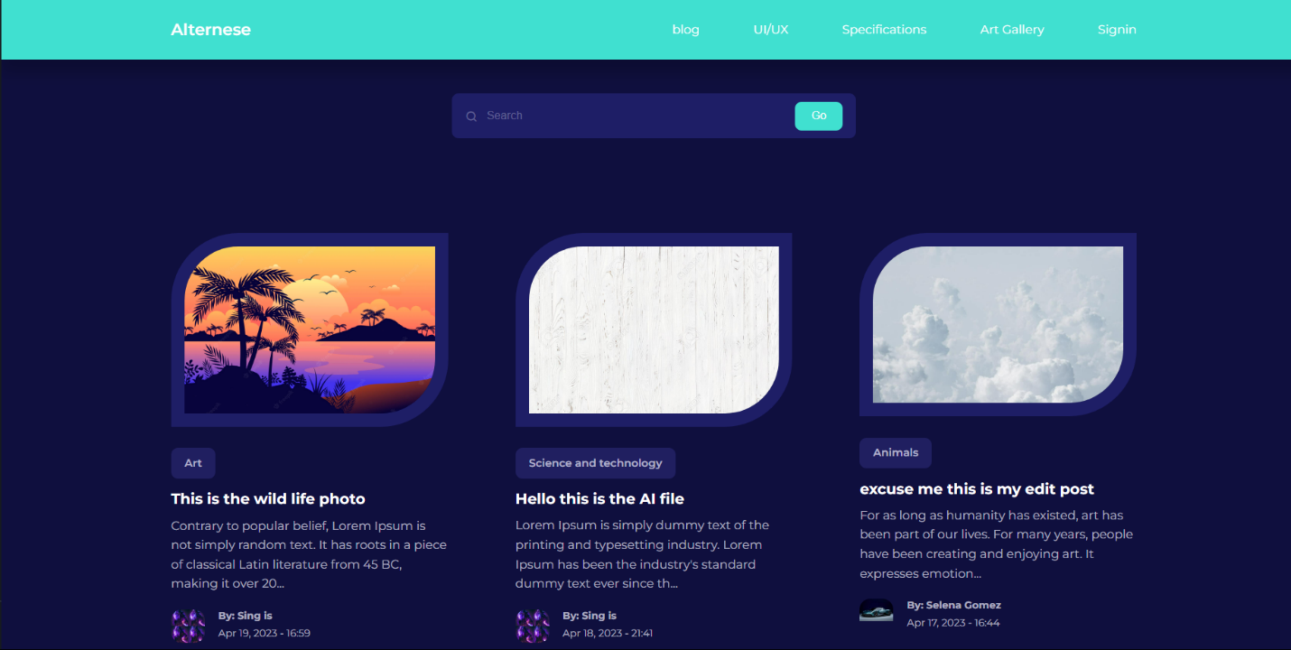

#### UI/UX Page

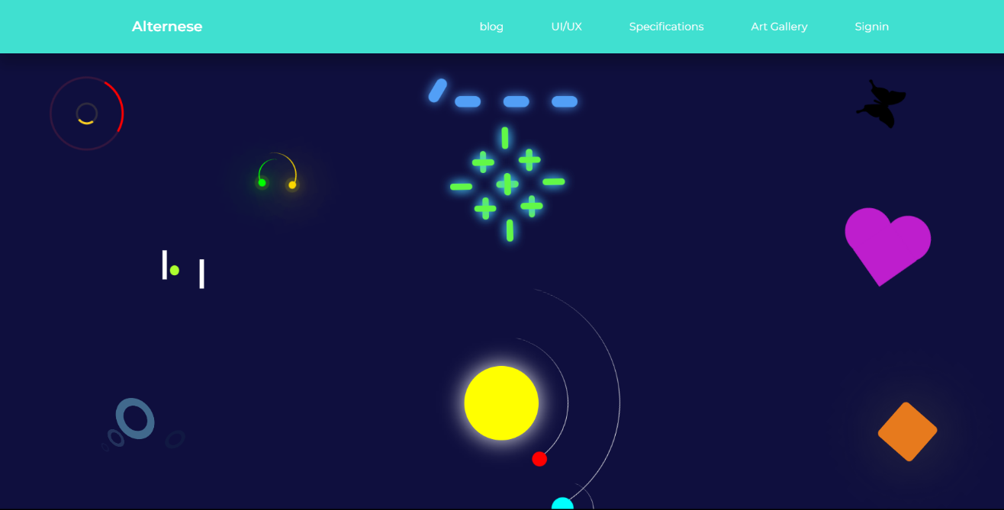

#### UI/UX Specification

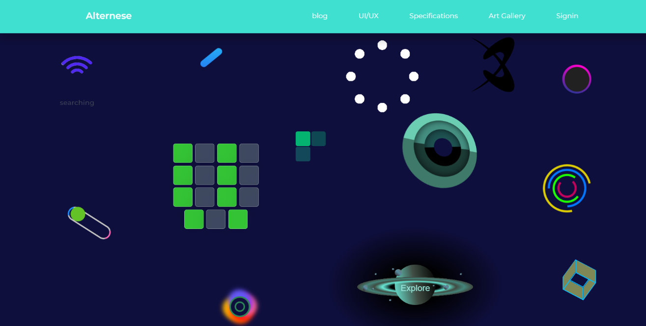

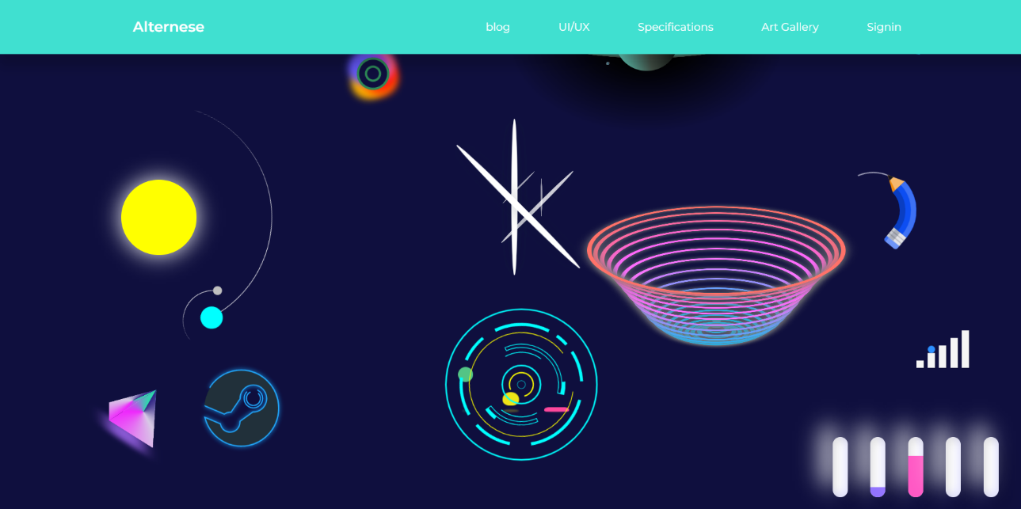

#### Art Gallery

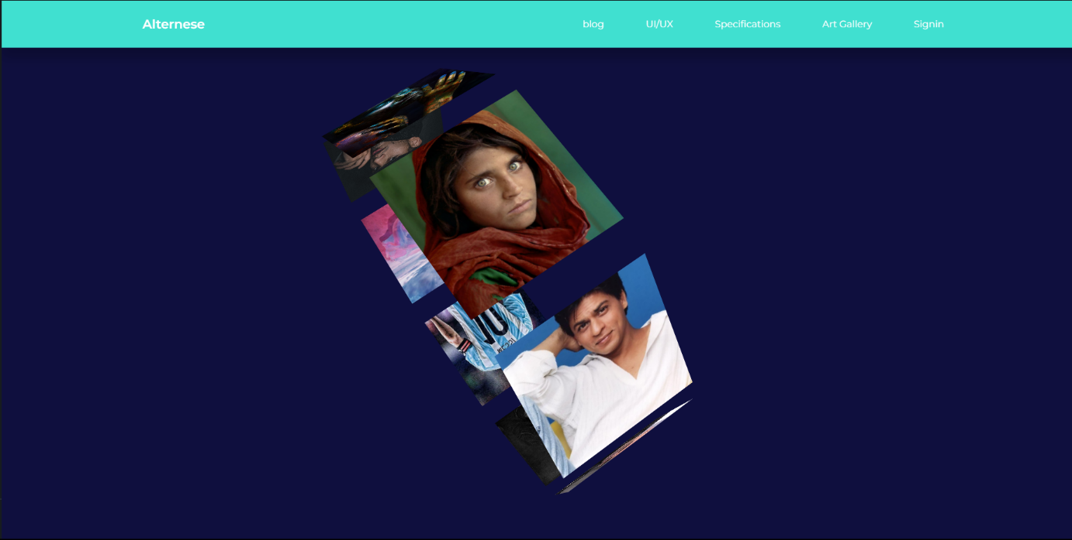

#### Sign in/Login page

#### Signup page

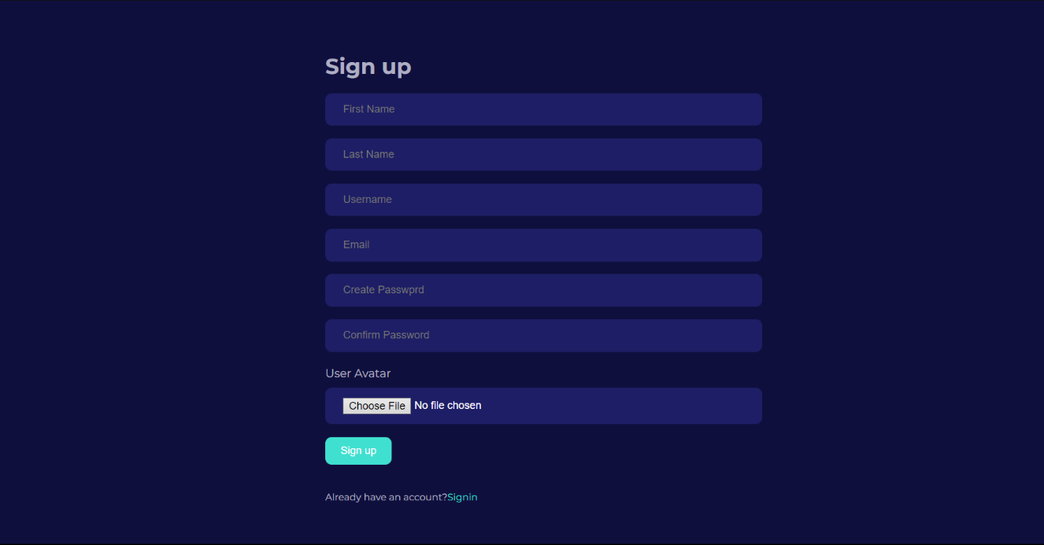

#### User’s Dashboard for Manage Post

#### 

#### User’s Add Post Page

### Admin’s Dashboard Page

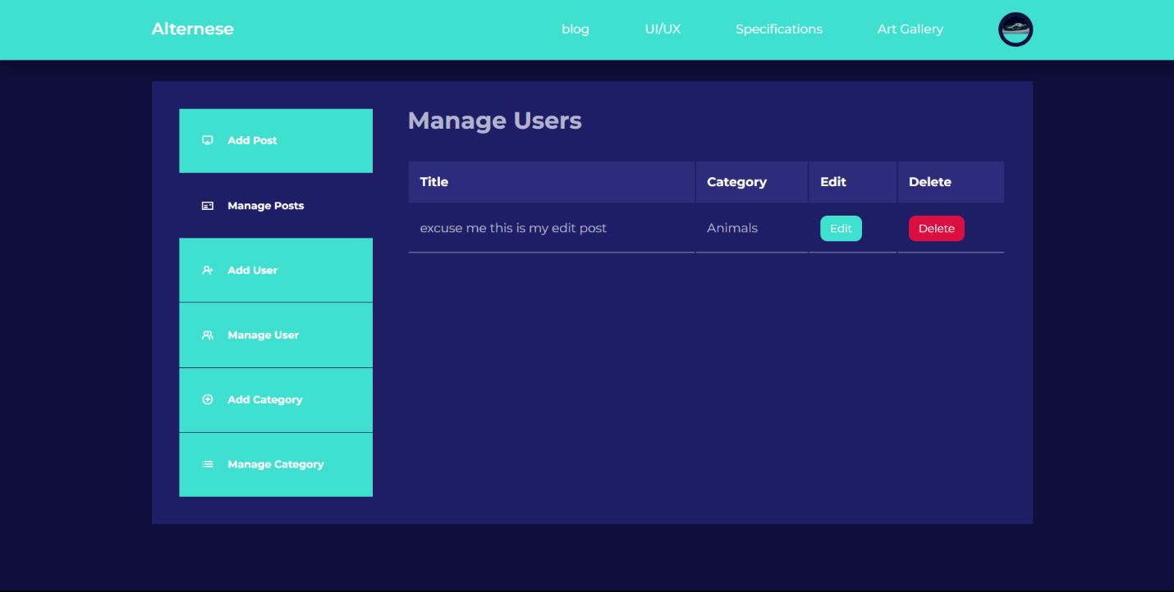

### Admin’s Add post page

### Admin Edit Post Interface

### Admin’s Manage User and Delete design page

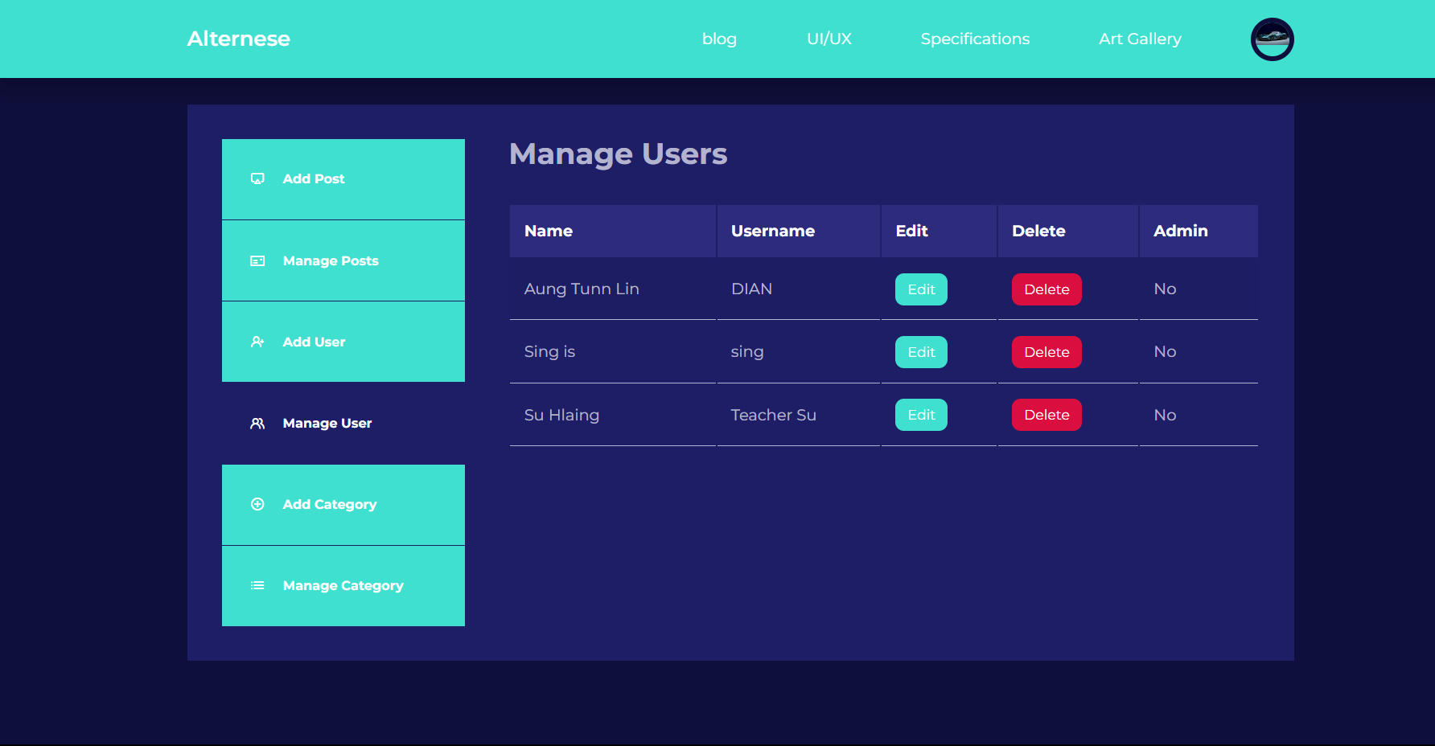

### Admin’s Add users design page

### 

### Edit User Design Page

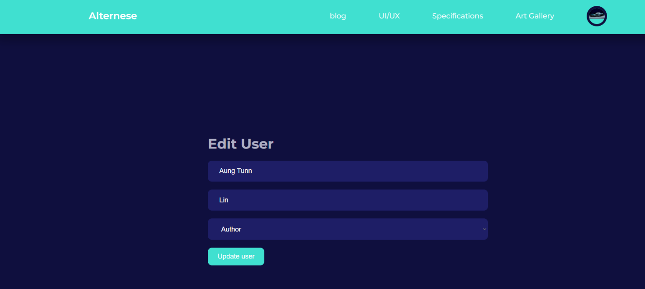

### Admin’s Manage and Delete Category Design Page

### Admin’s Add Category Design Page

### Admin’s Edit Category Design Page

### **1.5 Security Feature of the System**

In order to authenticate users and manage their access to private features and data, secure login procedures, password encryption, and role-based access control are implemented. Data is transferred securely over the network by using encryption protocols like HTTPS to secure communication between the web server and users' browsers. Implementing input validation and data sanitization techniques can help prevent common security flaws like cross-site scripting (XSS) and SQL injection attacks.

Protection against cross-site request forgery (CSRF) involves putting in place systems to validate and check the accuracy of user requests as well as safeguards against illegal activities taken on behalf of authorized users. patching and updating software on a regular basis maintaining the most recent security updates and fixes for addressing known vulnerabilities on the web application and its supporting software frameworks. Backup and disaster recovery: Performing routine backups of the program and its data to make sure that, in the case of any unanticipated problems or data loss, the system can be restored to a prior state. Setting up monitoring systems to find and address any security lapses or suspicious activity, as well as documenting significant security-related occurrences for auditing and investigative needs.

# **Section D**

## Testing Frame Data & Result

### 1.1Test Plan

#### No.1 Sign in / Login Page for User

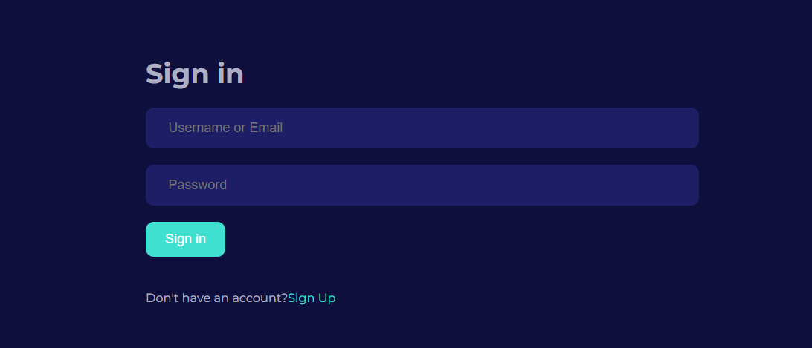

Sign in page contain username or email and Password field to sign in for the existing user and the admin. If the user or the visitor is new to system, they can sign up easily.

### 

If the user or Admin does not enter the data it will show the validation that “Username or email is required.

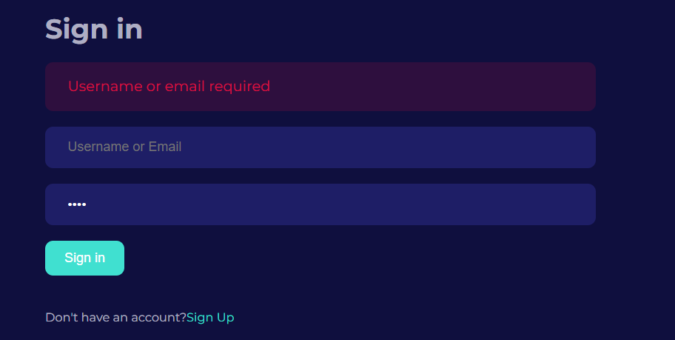

If the user just types the password and click sign in it won’t proceed because the Username or email is required.

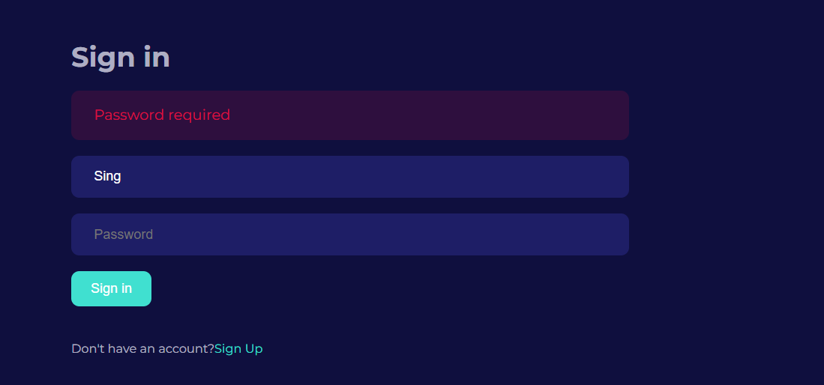

If the user does not enter the password, it will show the field that password is required

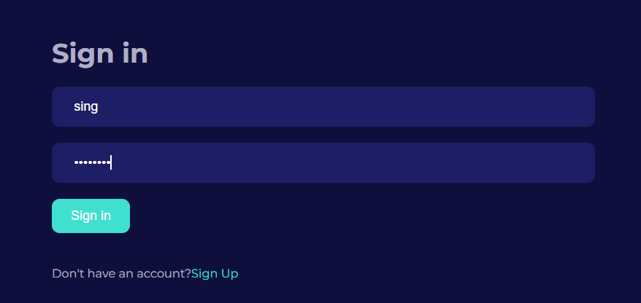

If the user enters the correct Name and the password that match in the Database it will take you to the user’s Dashboard page

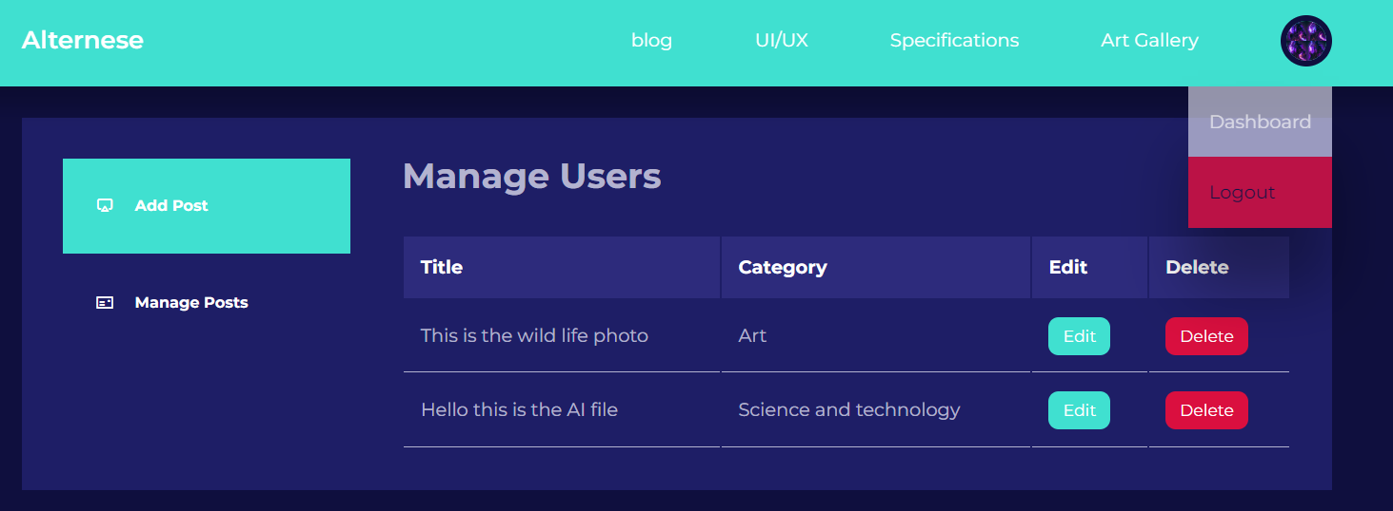

If the user enters the correct username and password in the sign in page it will take you to the user’s Dashboard page. If the user wants to logout just put pointer on the avatar profile it will appear the option Dashboard and the logout option. Out of these the user can select logout to logout the page.

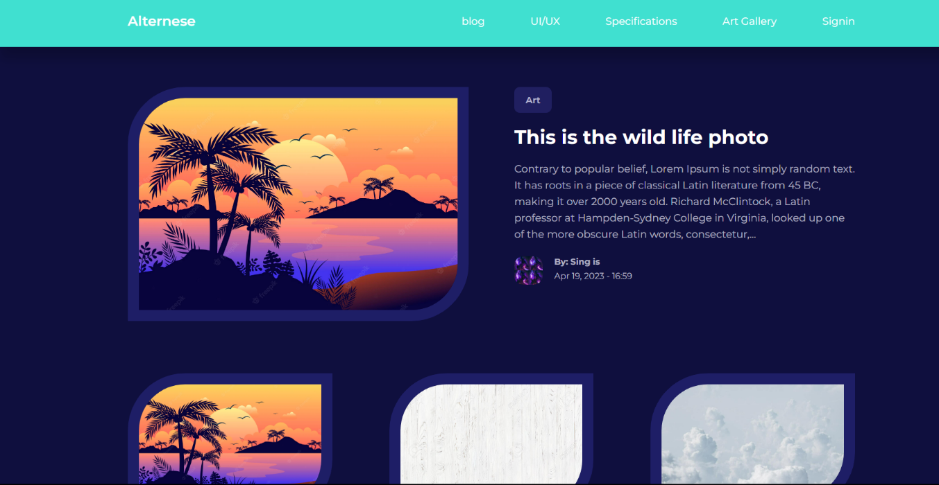

After the logout page it will take user to Welcome page where user can view the post and get the knowledge from the post.

### No.2 Sign in / Login Page for Admin

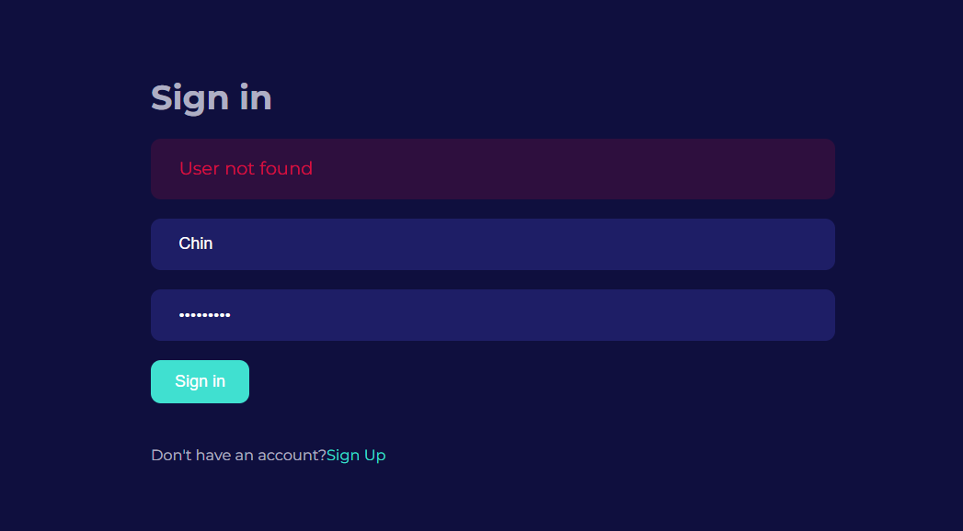

If the admin enters the wrong username it will validate by showing that User not found

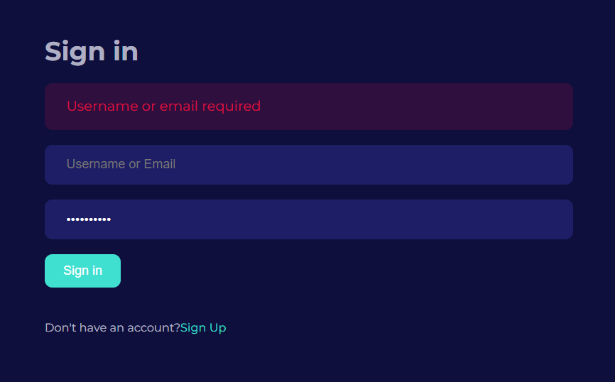

If the admin just types the password and click sign in it won’t proceed because the Username or email is required.

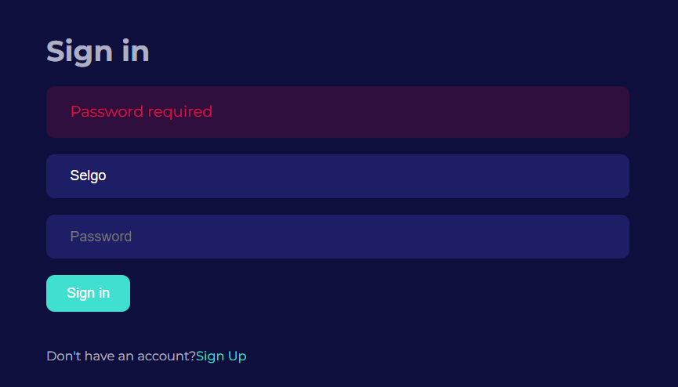

If the admin does not enter the password, it will show the field that password is required.

If the admin enters the correct Name and the password that match in the Database it will take you to the admin’s Dashboard page.

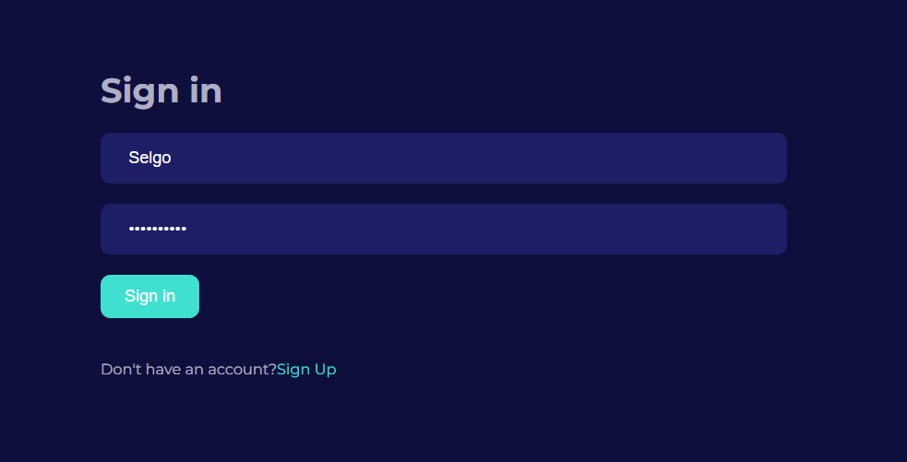

This the Page of Admin’s Dashboard where the admin can manage the Users, Post and its related category. The admin can logout to go back to the user’s page.

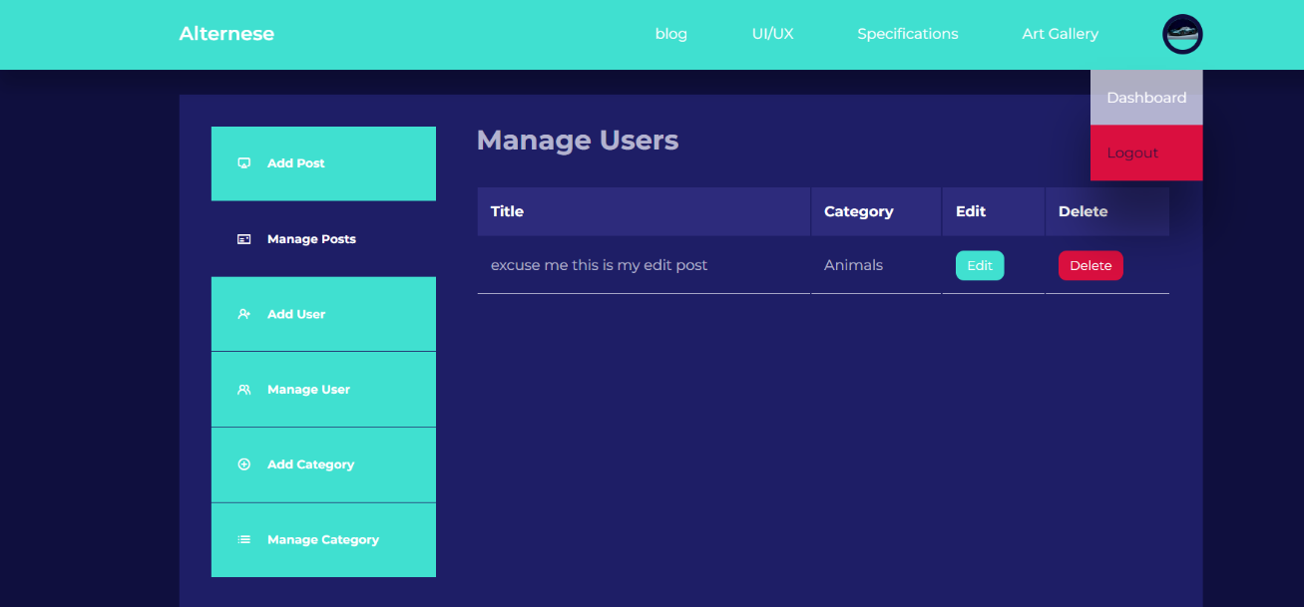

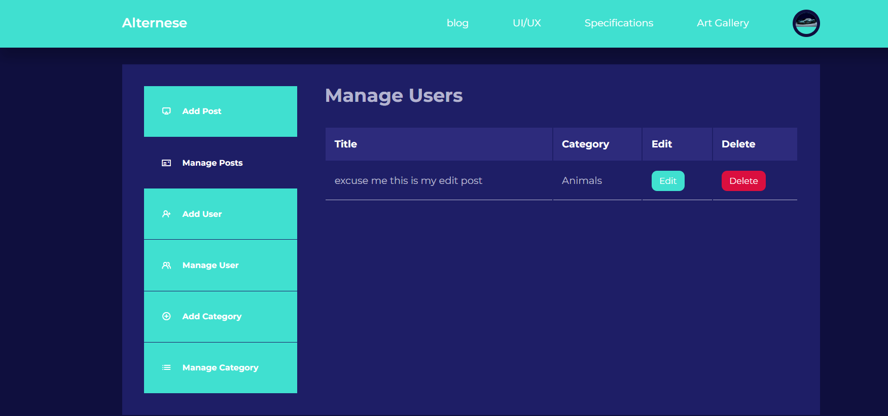

#### No.3 Sign up for new user

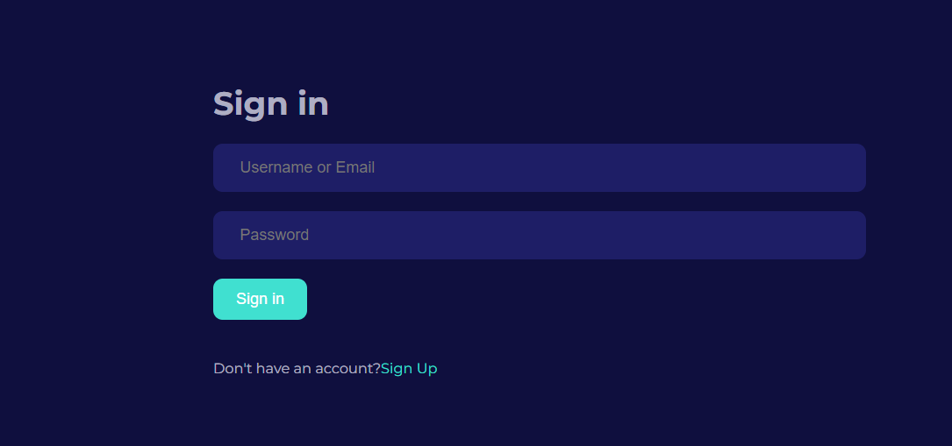

The new user can register to become the part of this system by simply registering on the Sign-Up page

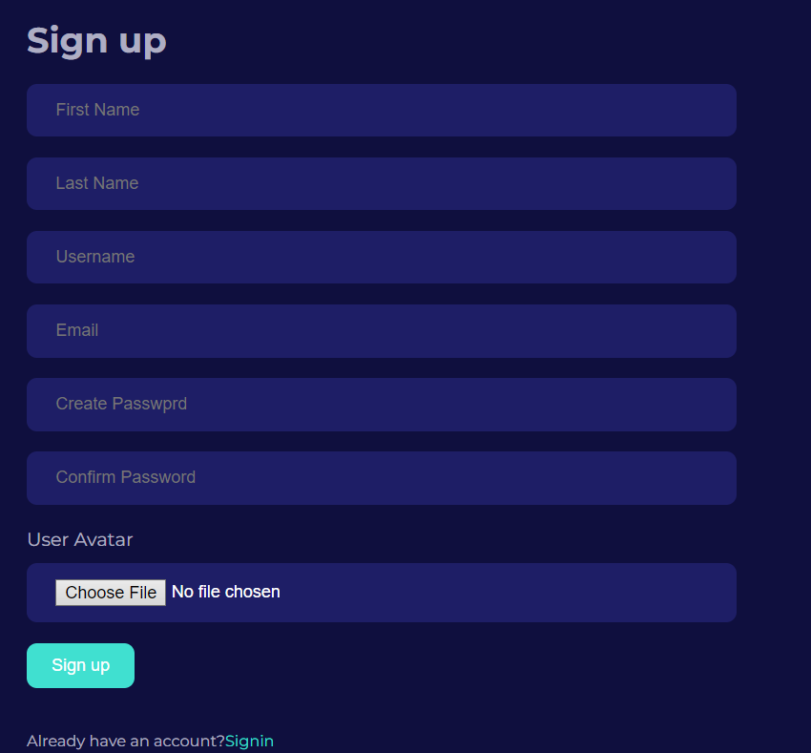

This is the Signup page for the new user. The new user can simply insert the personal information to sign up. It consists of Firstname, Lastname, Username, Email, Password and the Avatar.

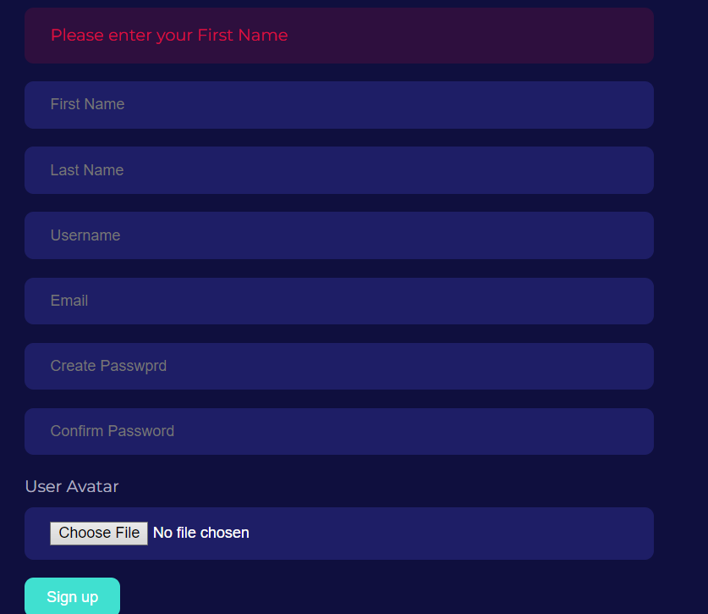

The new user cannot submit the sign up without entering any data. It validates to Enter your first name.

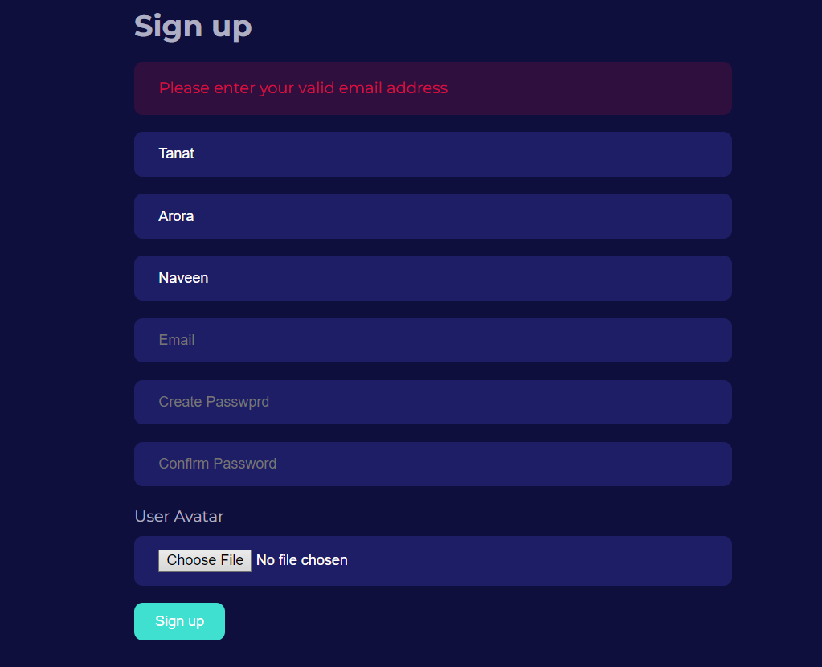

For the new user it is not enough to just put the name and the username because it requires the email address to keep an update of the post.

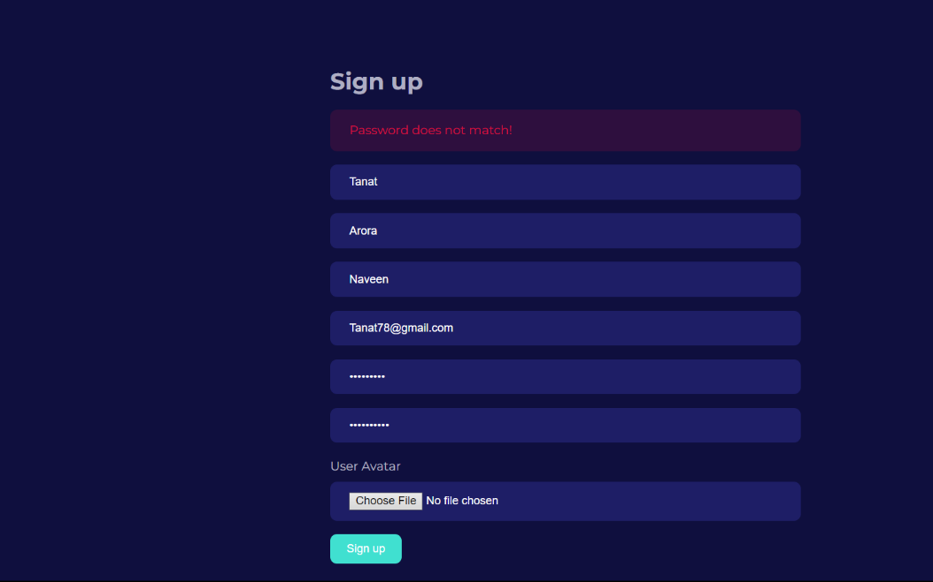

If the user enters all the information including the password but if the confirm password does not much the original password it will validate that password does not match as shown in the snap.

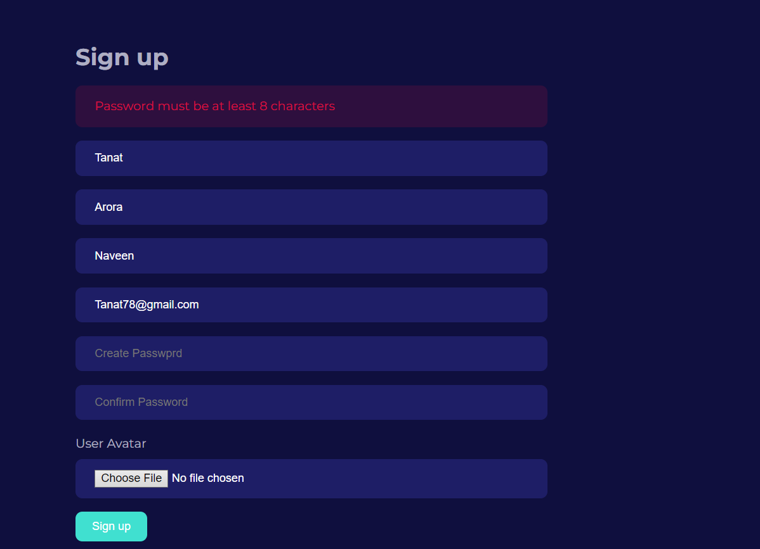

Again, the password must be at least 8 characters as required by the system for its high security.

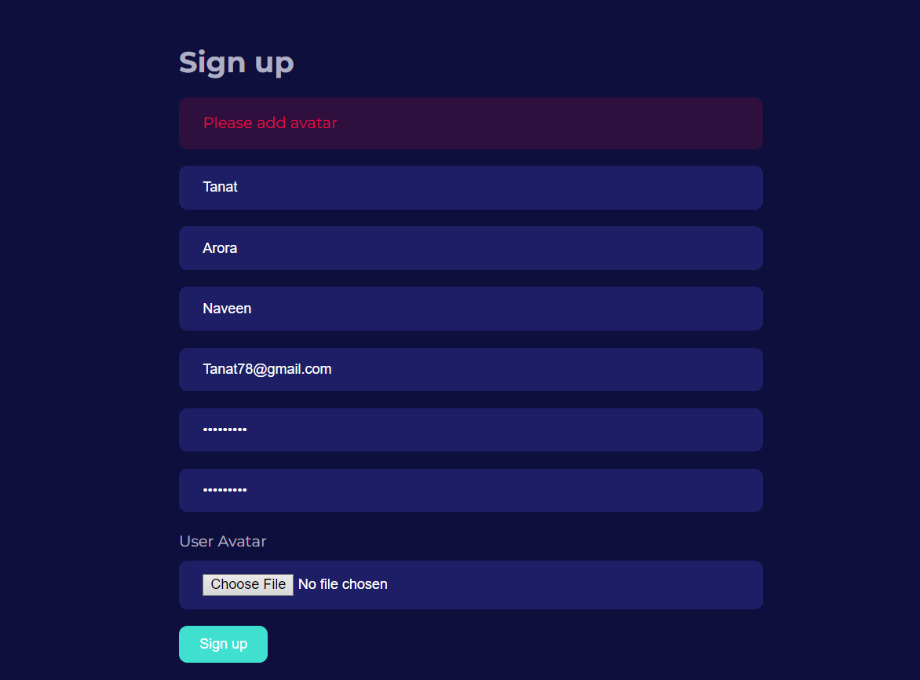

If the user has entered all the information correctly the user still needs to add an avatar for the differentiate of the user

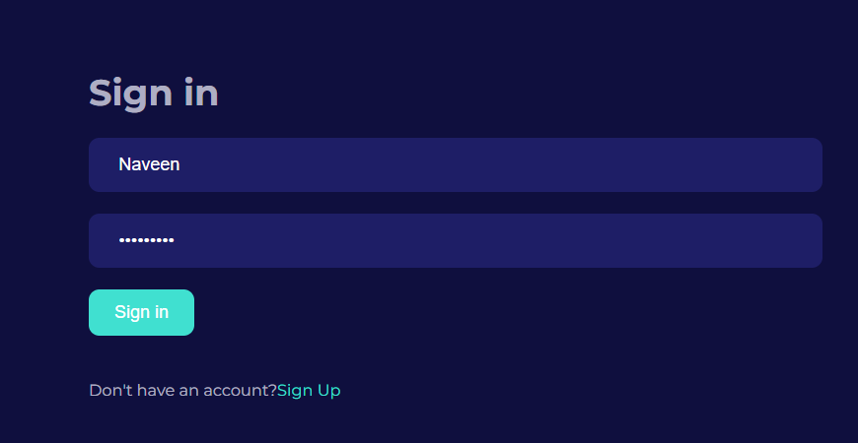

After the new user has registered the sign up the user must need to sign in/ login back to get the user’s dashboard.

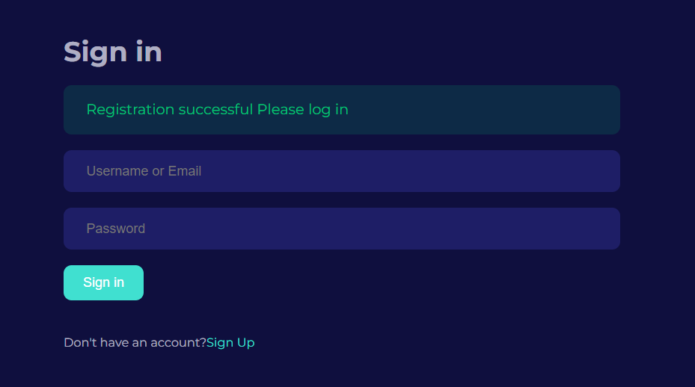

After the user had successfully login it will validate that Registration successful.

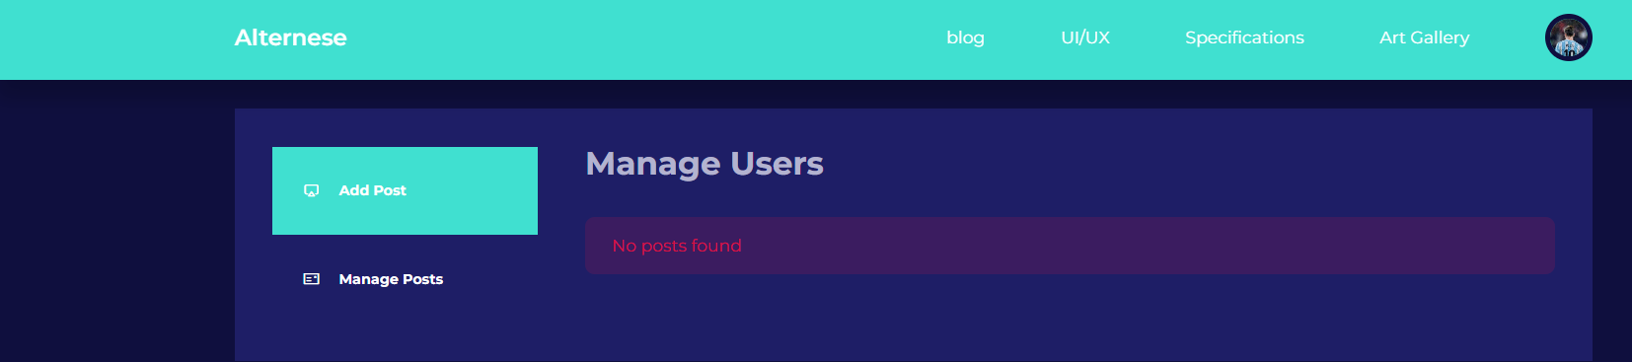

These two snaps are the new user’s dashboard in which the new user can easily add post and manage post.

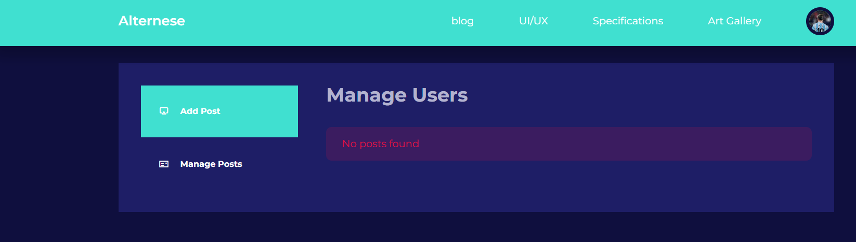

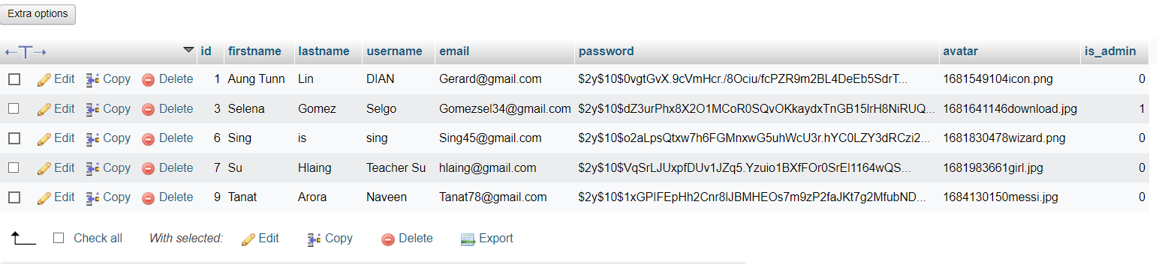

This snap is the php My admin in which you can easily see that the new username called Naveen has added to the table.

#### No.4 User’s Dashboard Manipulation

##### Add Post

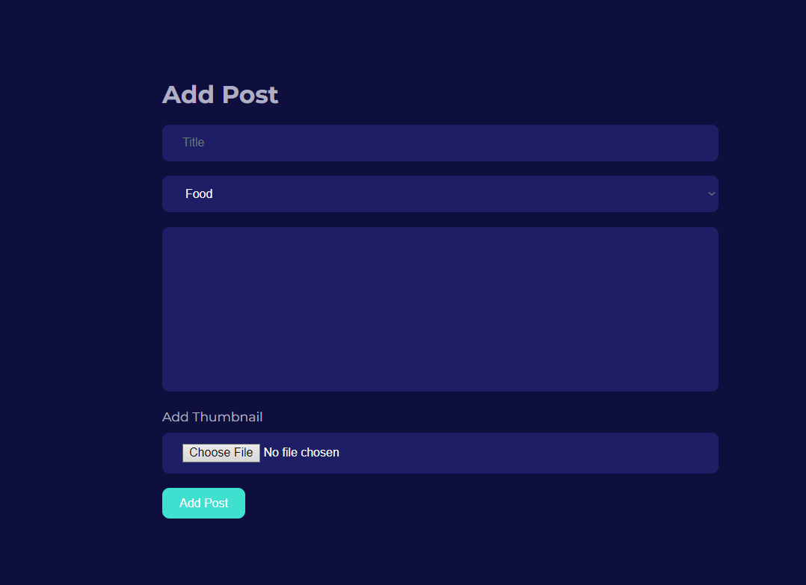

The user can easily add a post with a title, selecting category, content and the thumbnail as shown in this snap

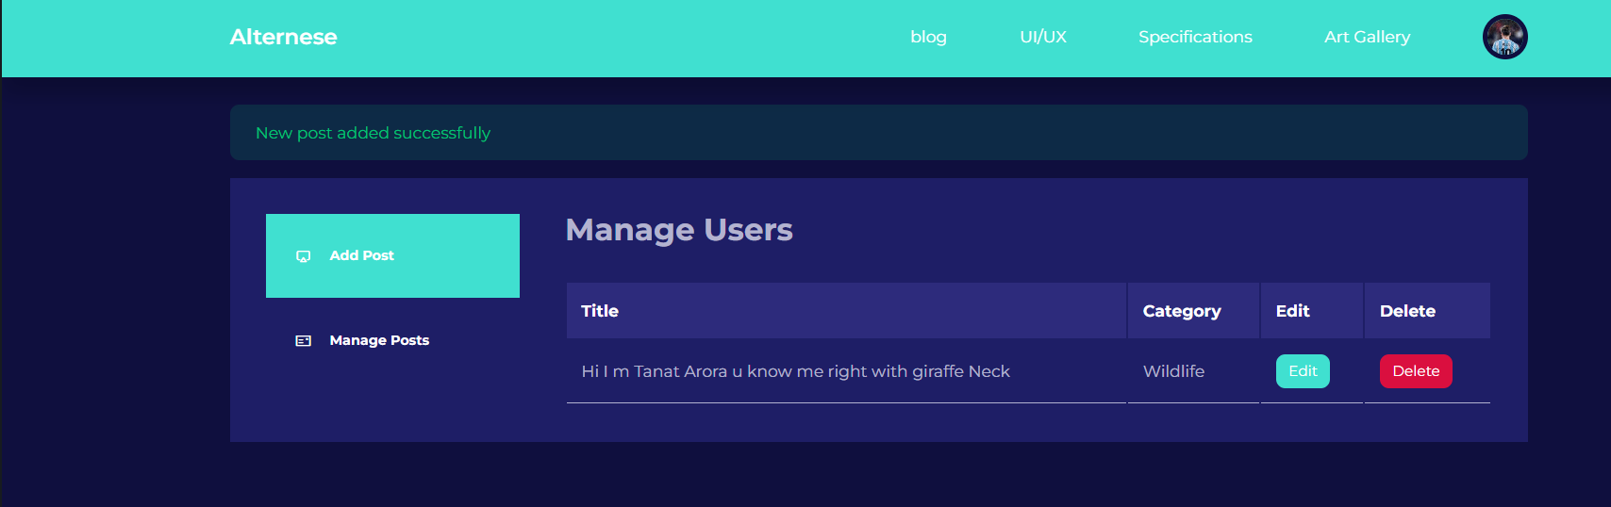

The user can easily edit the posts and the delete the post easily from here.

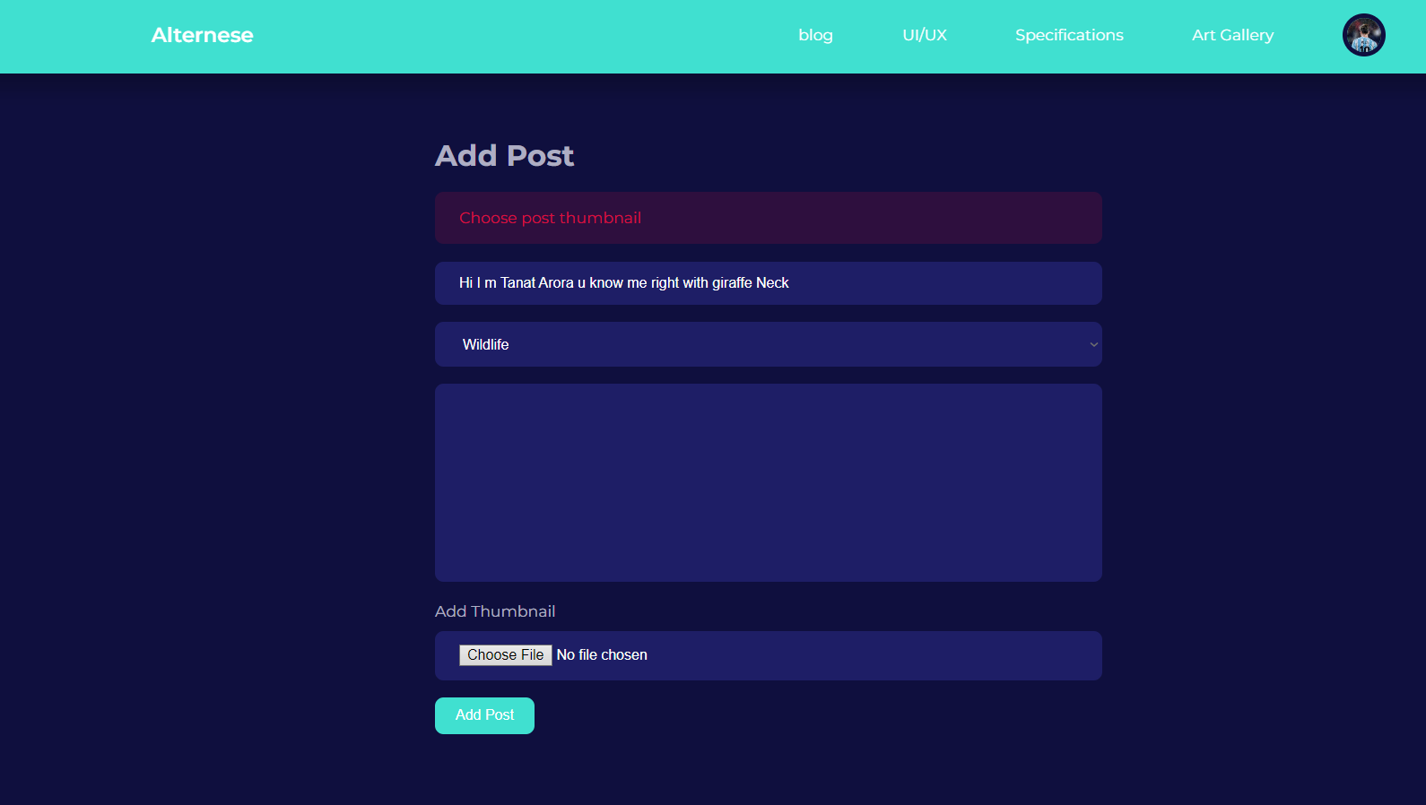

After filling all the required information demanded by the system the user still have to choose the thumbnail for the post to be shown in the main webpage.

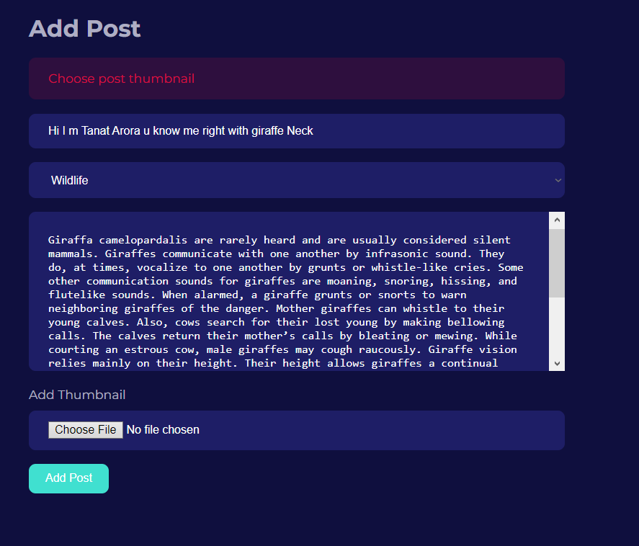

This is the form where all the information has been inserted

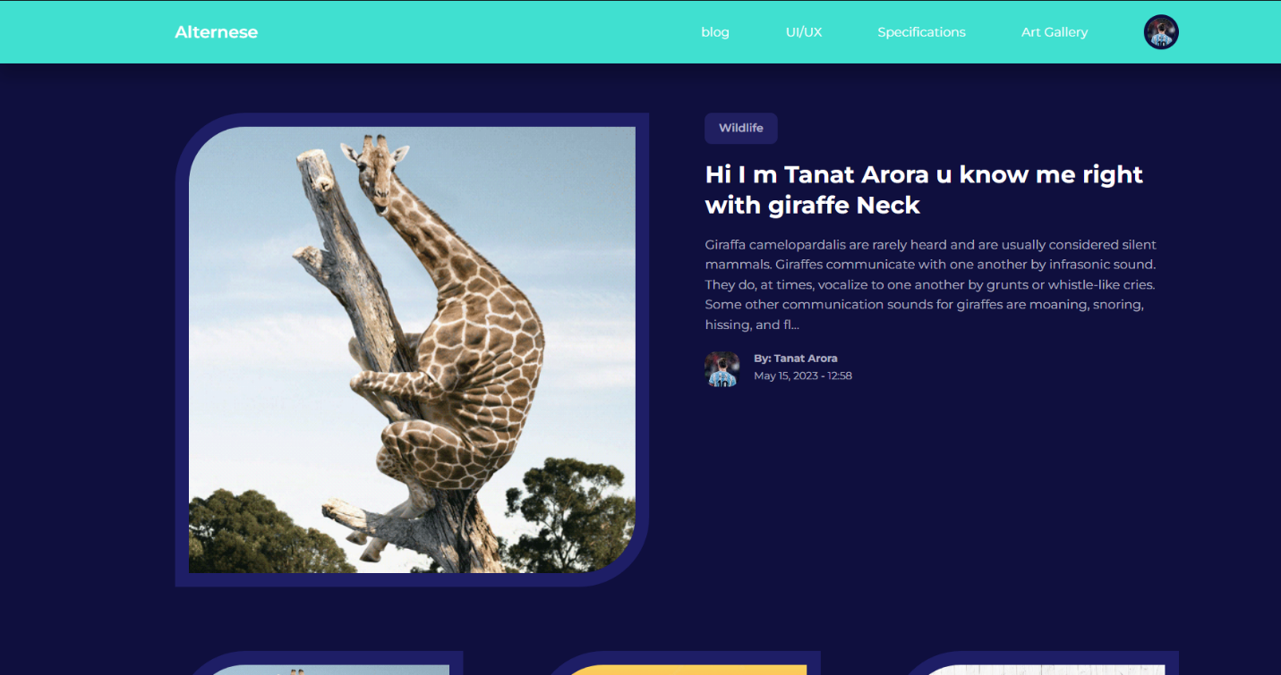The post that is uploaded by the new User Tanat Arora is as featured displayed on main webpage.

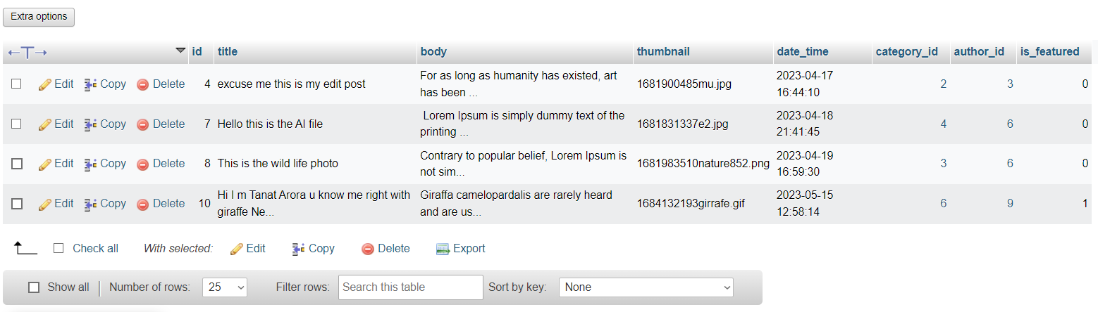

The post uploaded by the new user Tanat Arora is already reached to the database as shown in this snap.

##### Edit Post

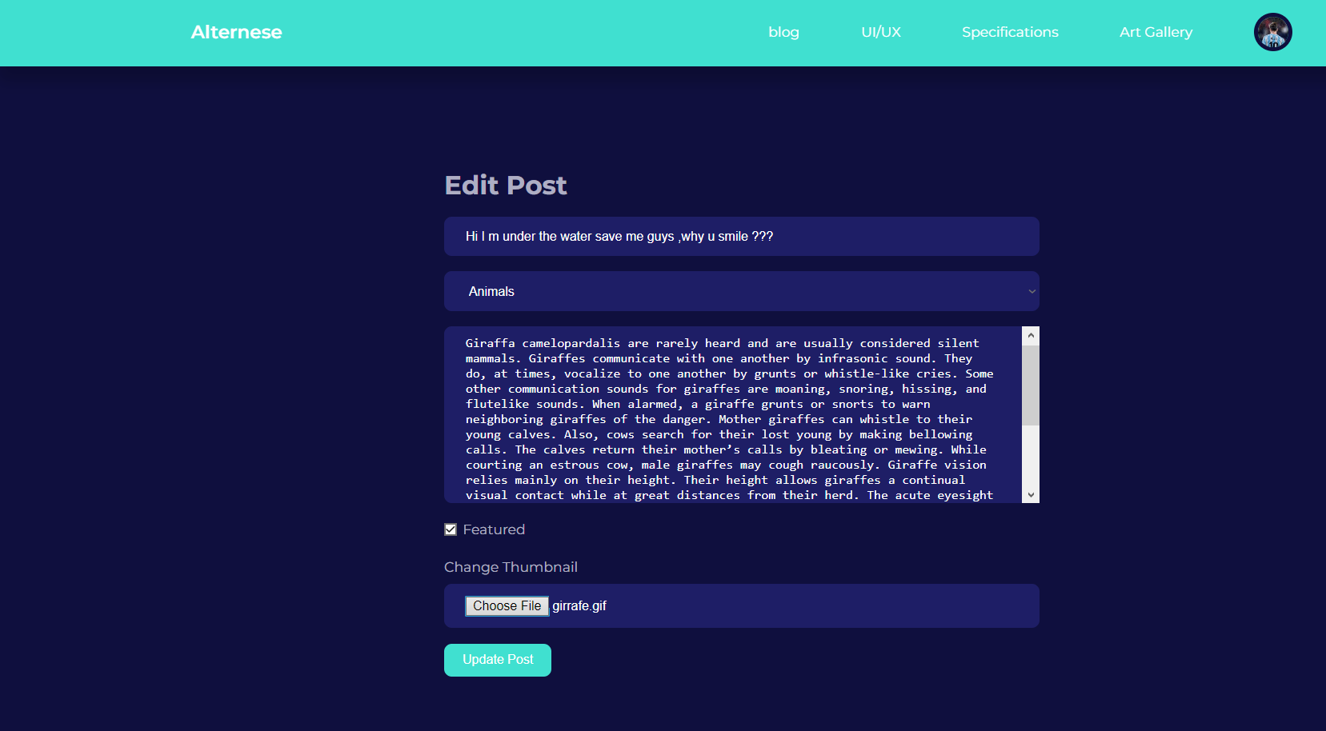

The user can easily edit the post while filling all the requirement information. The data fills in the snap is totally different from the Add post.

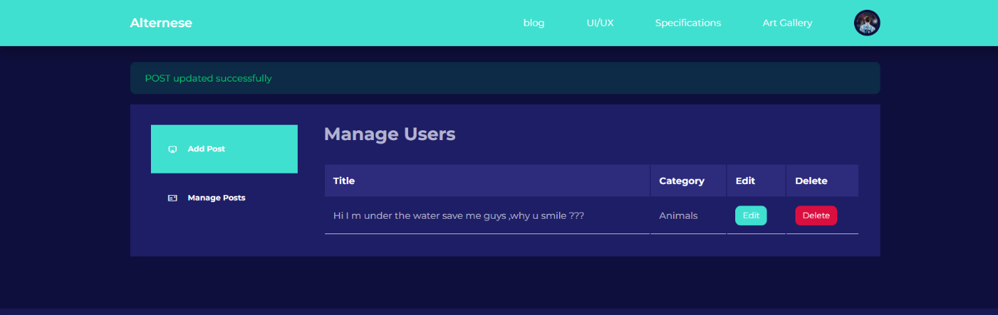

After the user fills the required information in the edit post and submit the edit button the validation shows that the post has updated successfully.

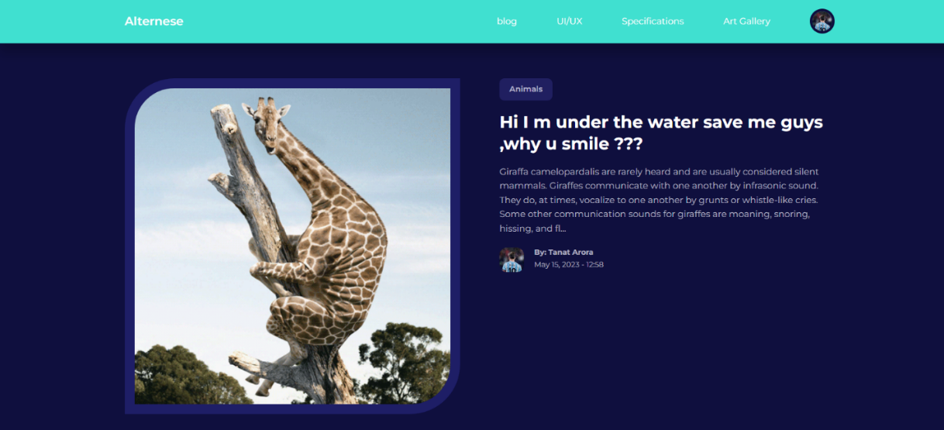

Now u can see the different of the title as the user has edited. Shown in the snap.

##### Delete Post

The user can delete the post easily by clicking the red delete button to delete the post. After deleting the post, the validation shows that the post has been deleted successfully. In the second snap you can see that the post has been deleted.

#### Admin’s Dashboard Manipulation

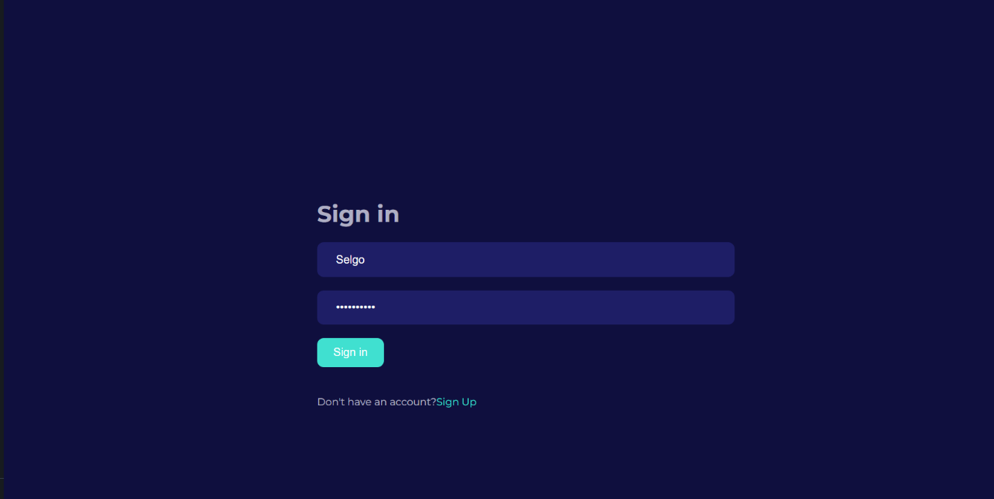

This is the sign in page where the admin enters the correct username and the password.

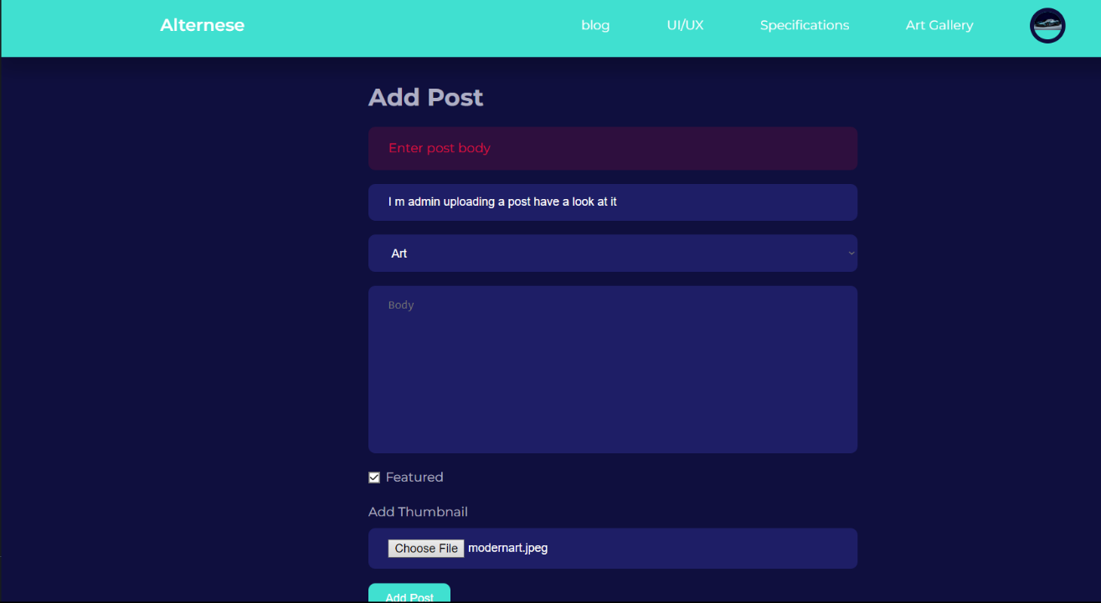

The admin can add the post by entering the necessary data in the field. The admin cannot post the Post content without filling the content as shown in the pic. If does it will validate “Enter the post”.

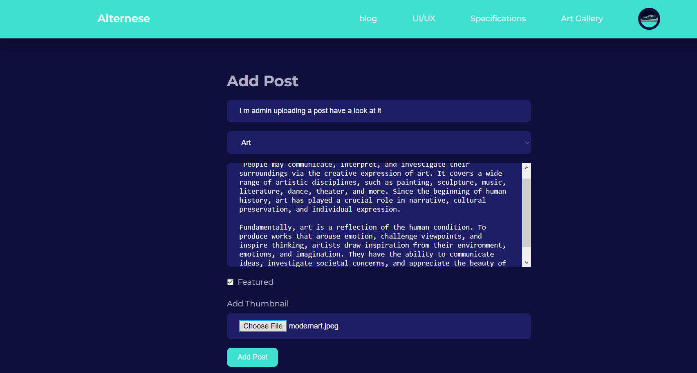The admin has filled all the data correctly in the particular filed as shown in this snap.

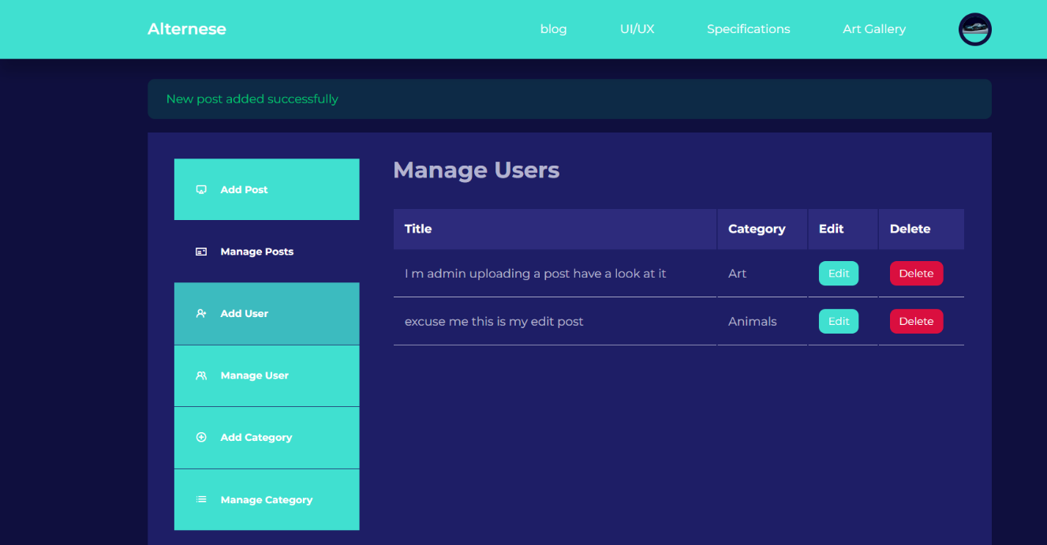

After the admin click the Add post it will validate that the new post has added successfully.

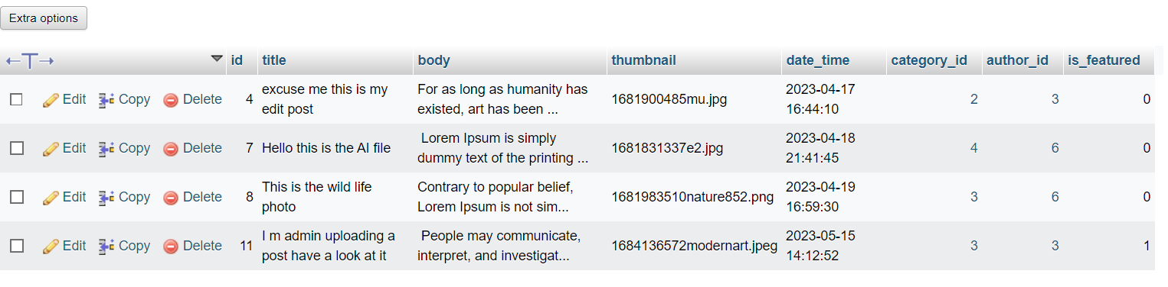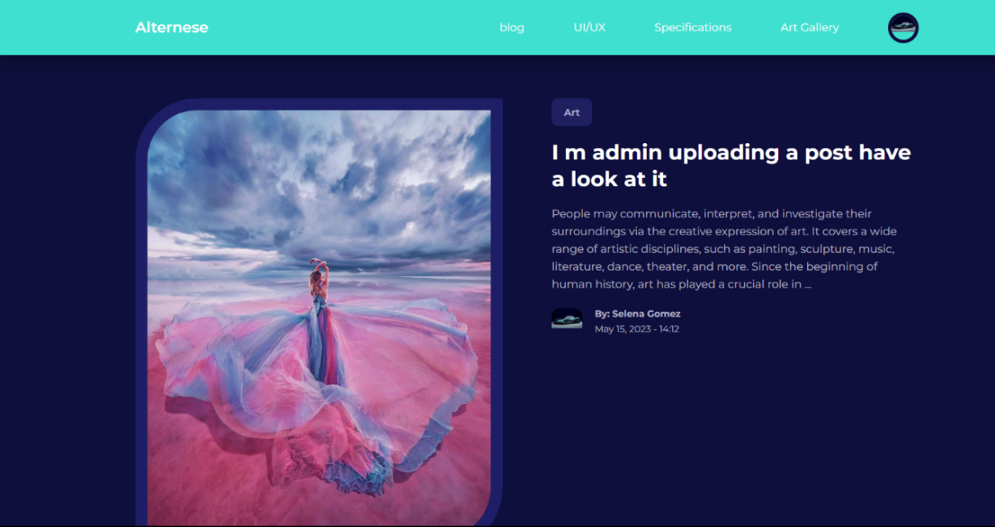This snap shows the Pic where it has been uploaded by the admin

In the database it shows that id 11 is added as shown in the pic

##### Edit Post

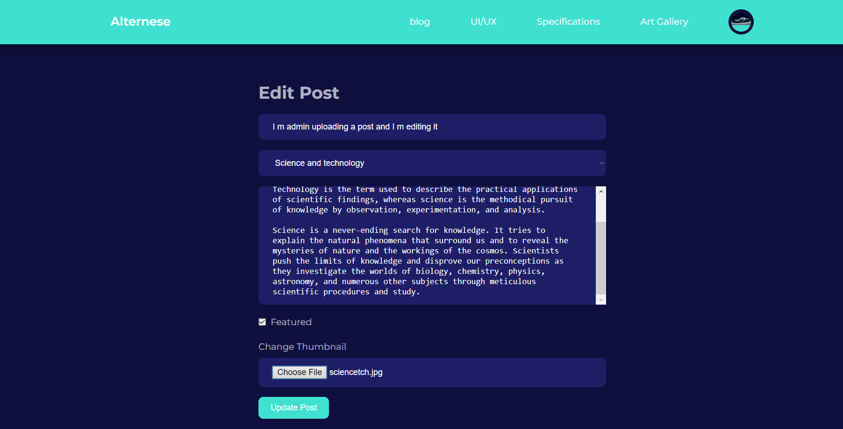

In this snap it has shown that the admin has edited the entire post by filling the different data

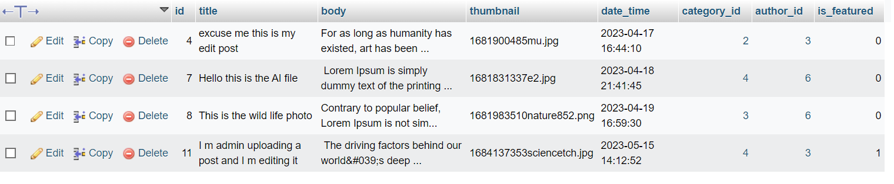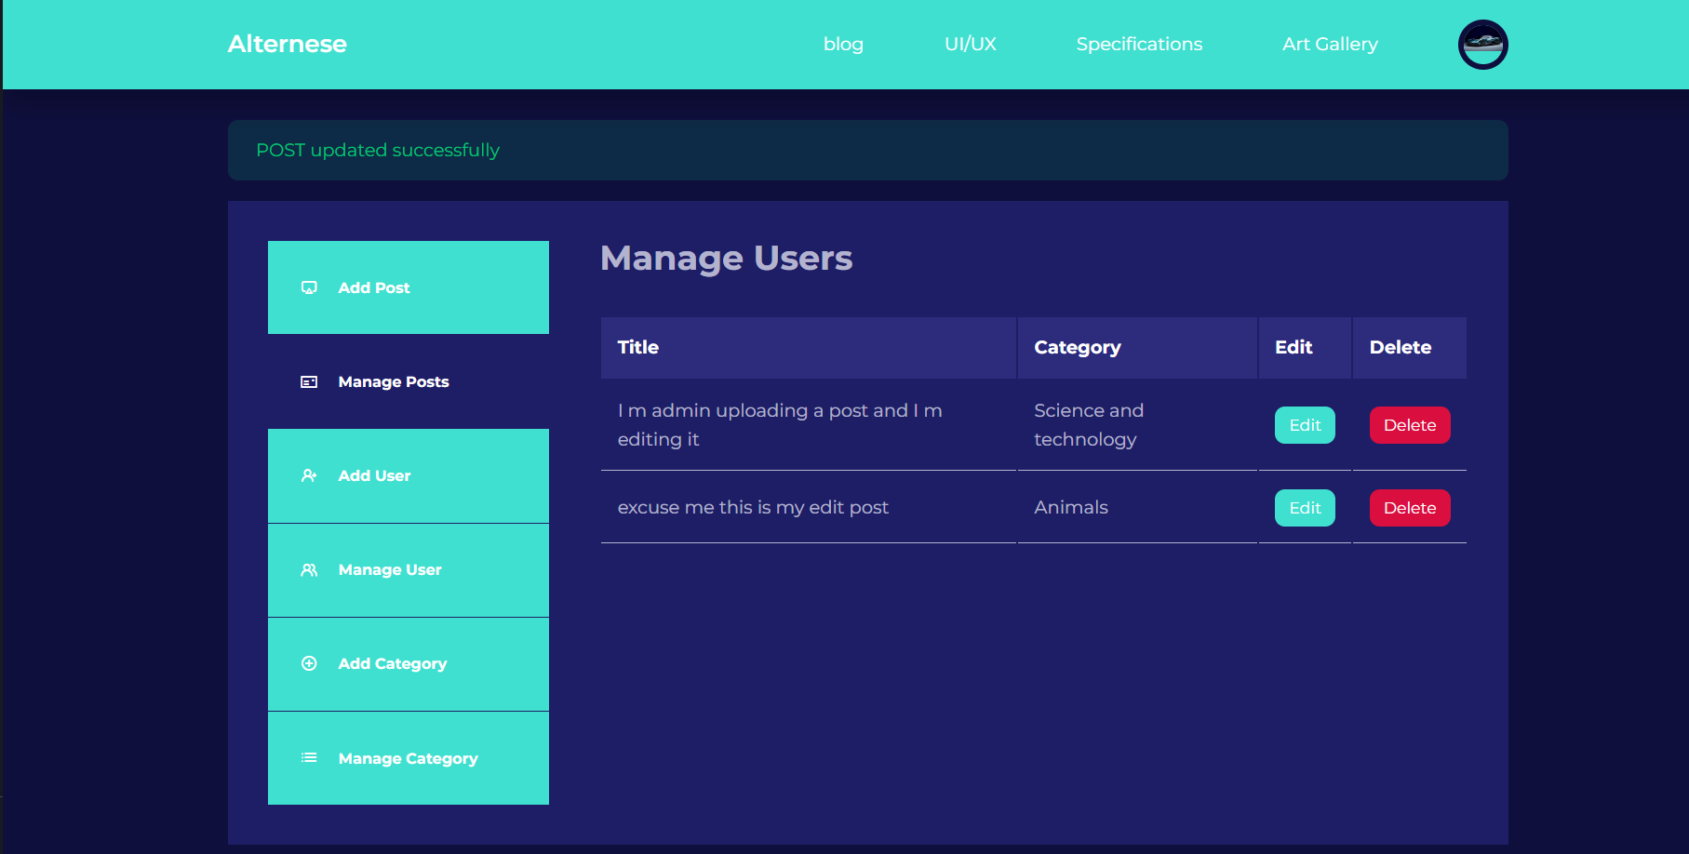The snap shows that the post has been updated.

In the database it has shown that the admin has successfully edited the entire post.

##### Delete Post

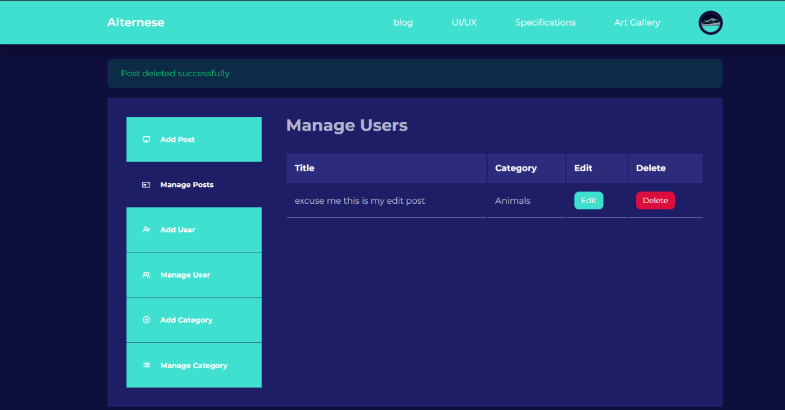

The admin has deleted the post successfully as shown in this pic

The database shows that the post has been deleted

##### Add Users

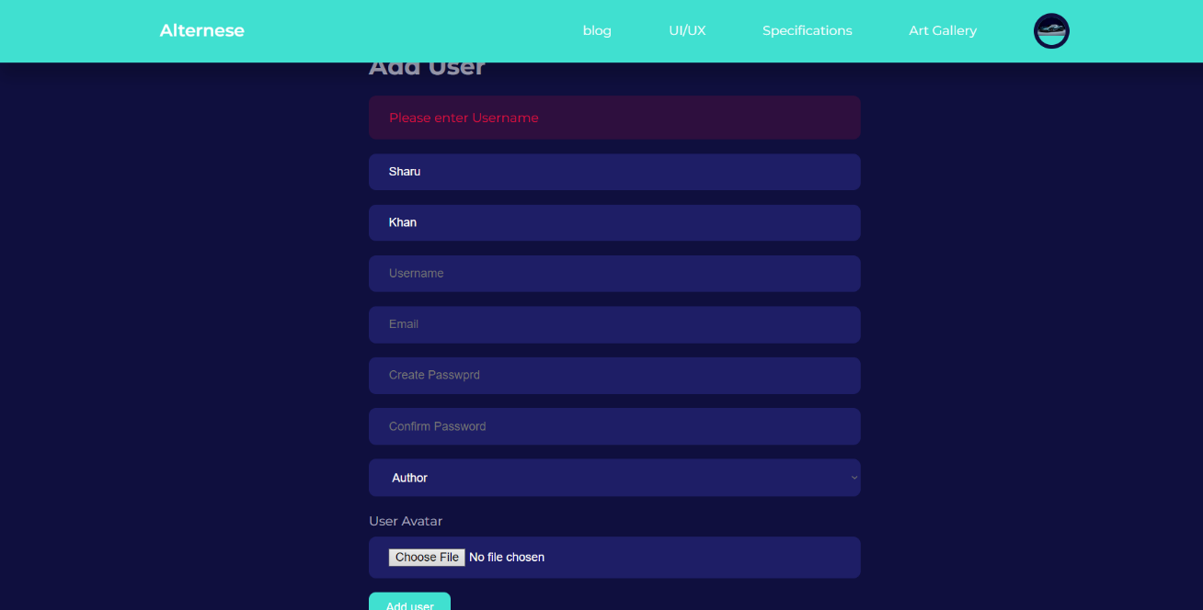

The admin can add user but if admin enters only first name and last name it will validate by showing to enter username.

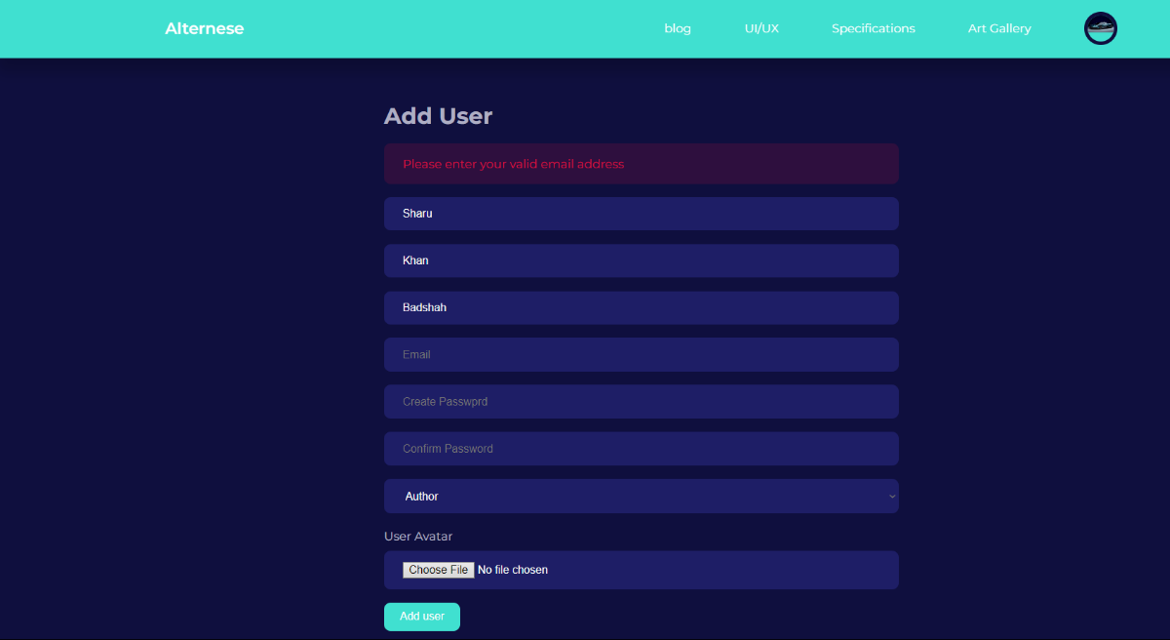

If the admin has entered username click the add post it will validate by showing to put valid email.

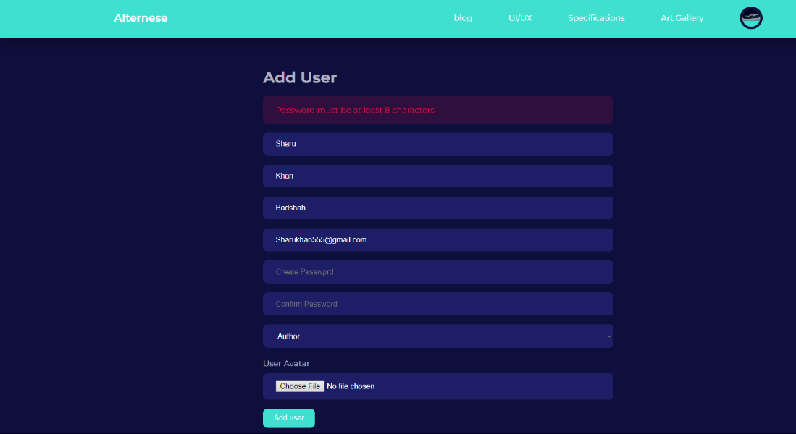The password is required for the high security otherwise it will validate that the password is required.

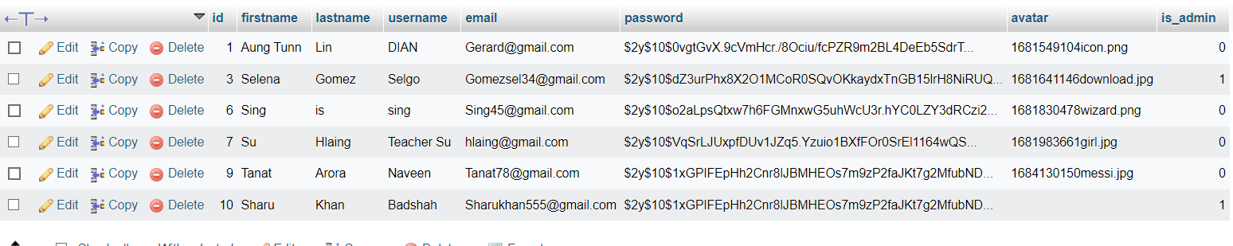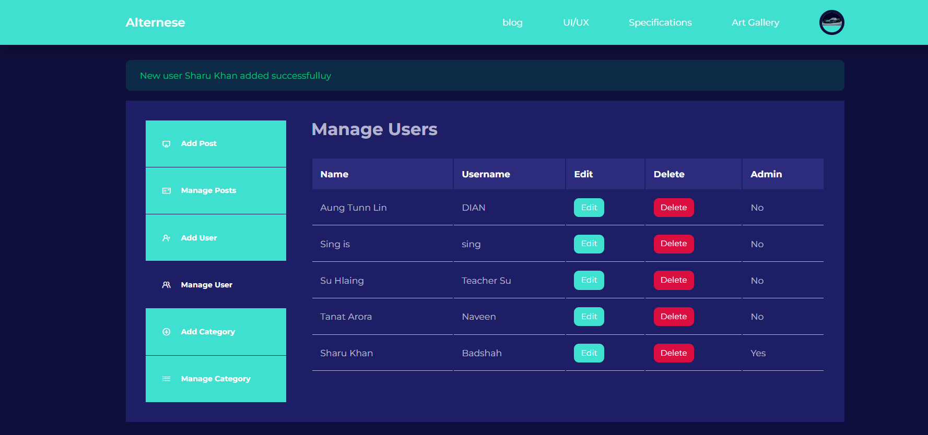After the admin has filled all the requirement validation the new user has been added successfully as shown above.

In the database it is stated that the new user Sharu Khan has been added.

##### Edit User

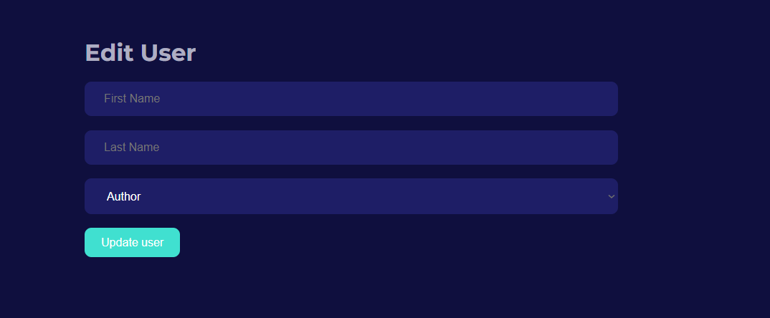

This is the Edit user page in which the admin has to fill first name and the last name to update the user.

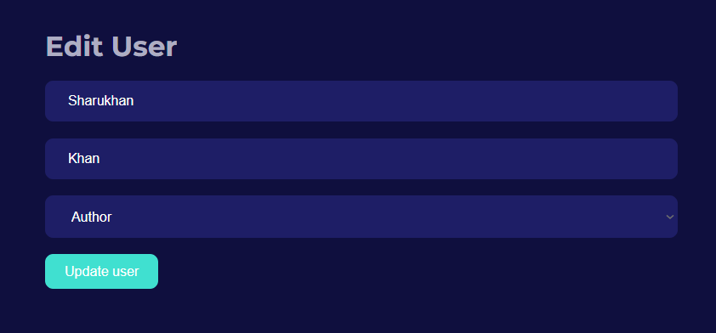

In this snap its shows that the user has filled the data in the edit form.

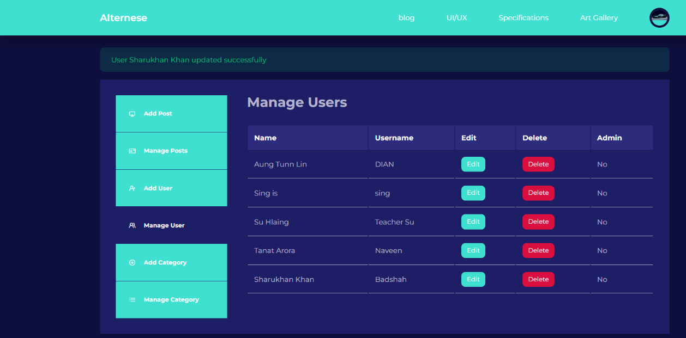

In this snap that the admin has already update the user’s name validating by showing the new users has been updated successfully

##### Delete Users

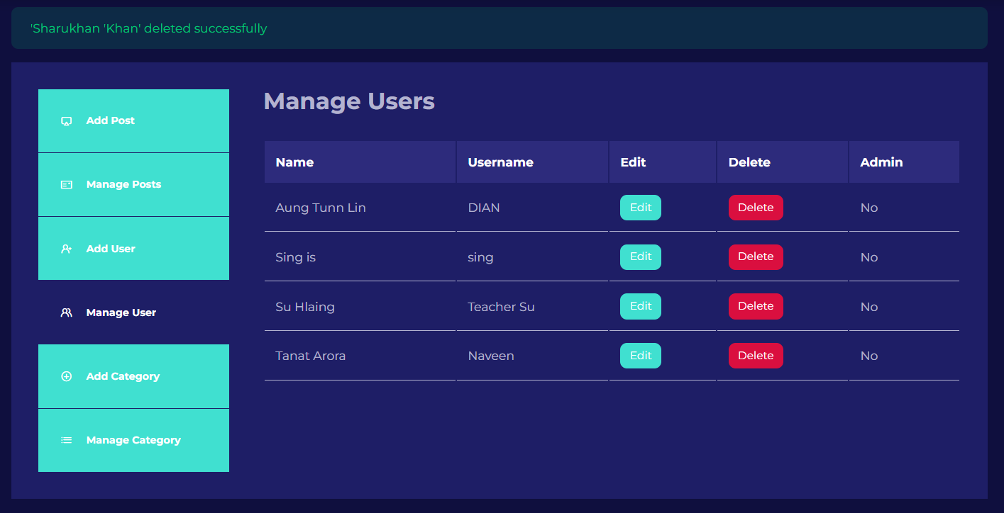

The admin can easily delete the user by clicking delete button and complete validation shows that users deleted successfully

##### 

In the database as you can see the user data has been deleted successfully.

##### Add Category

##### 

The admin can Add Category but if the admin does not enter the description it will validate by showing enter the description.

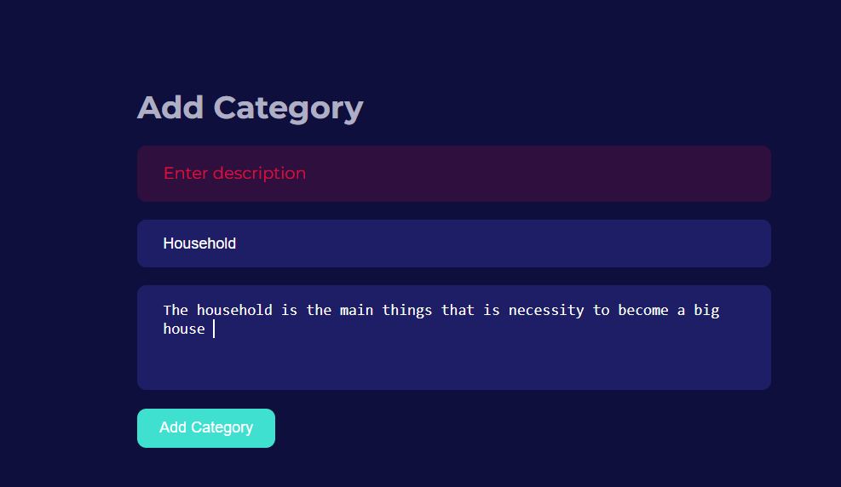After the Admin Enter all the requirement and submit Add category.

In this snap it shows that the household category has been added successfully.

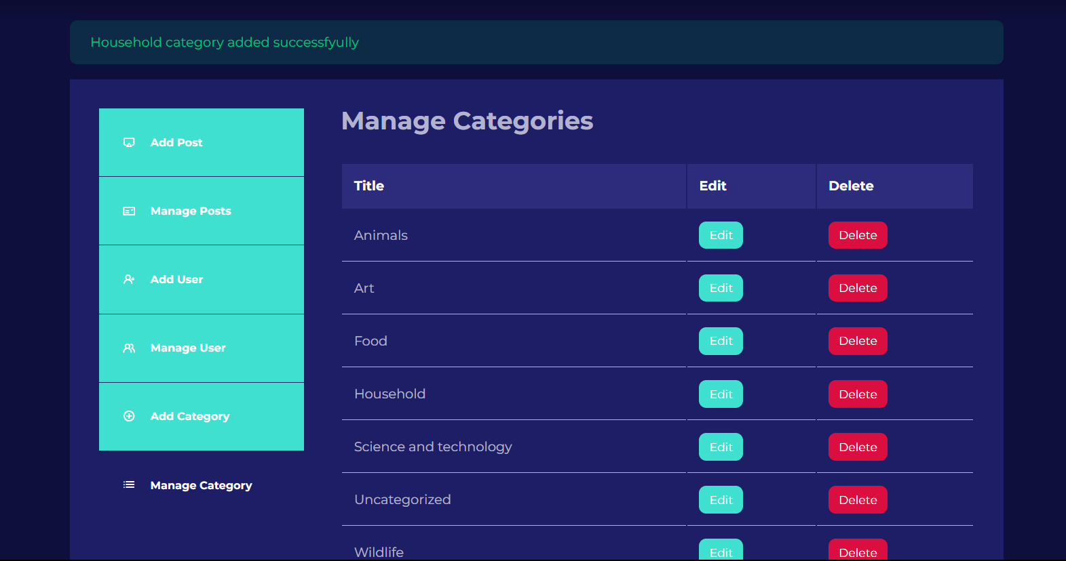

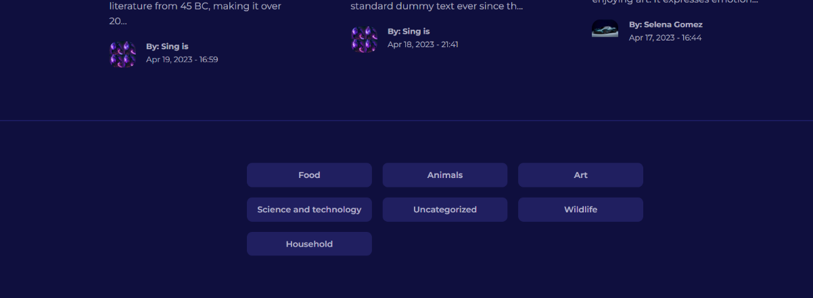

The category has been added as shown in the pics.

##### Edit Category

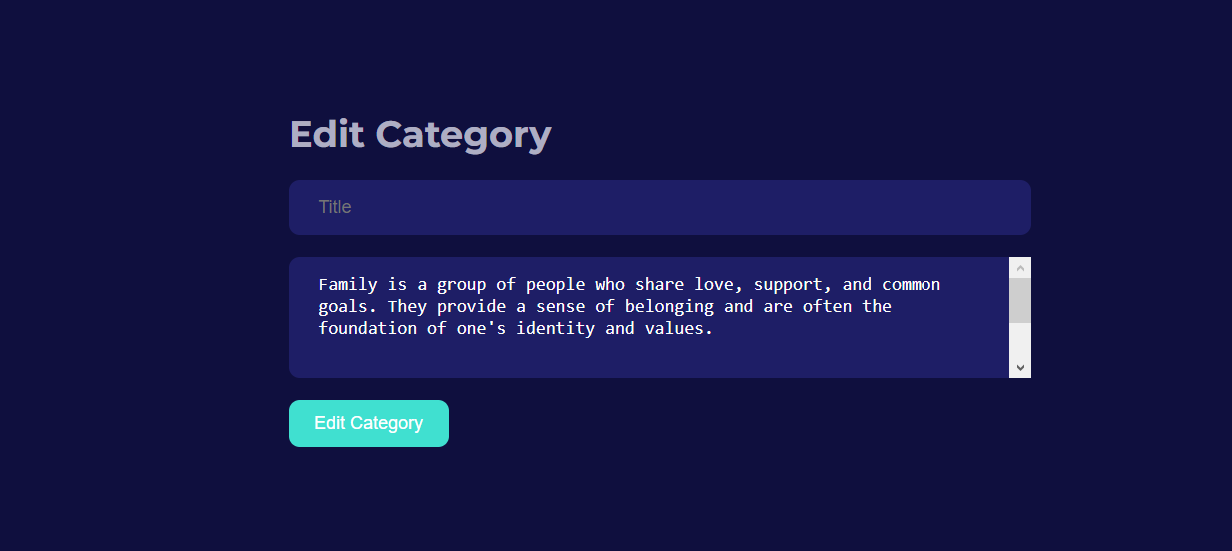

The admin can edit the category by entering the data as shown in the pic.

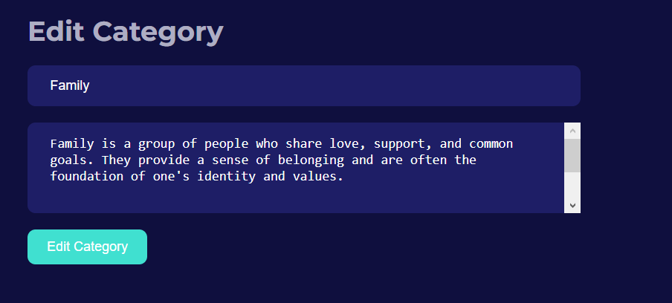

The admin can edit by filling all the data.

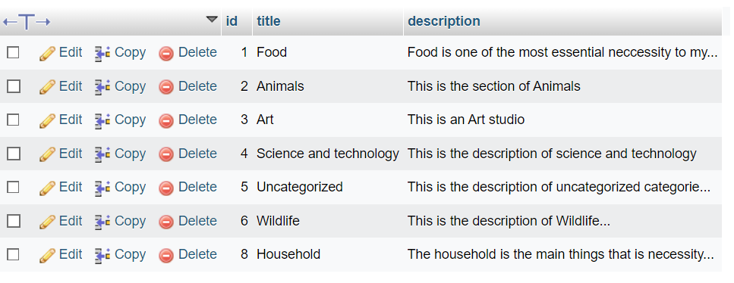

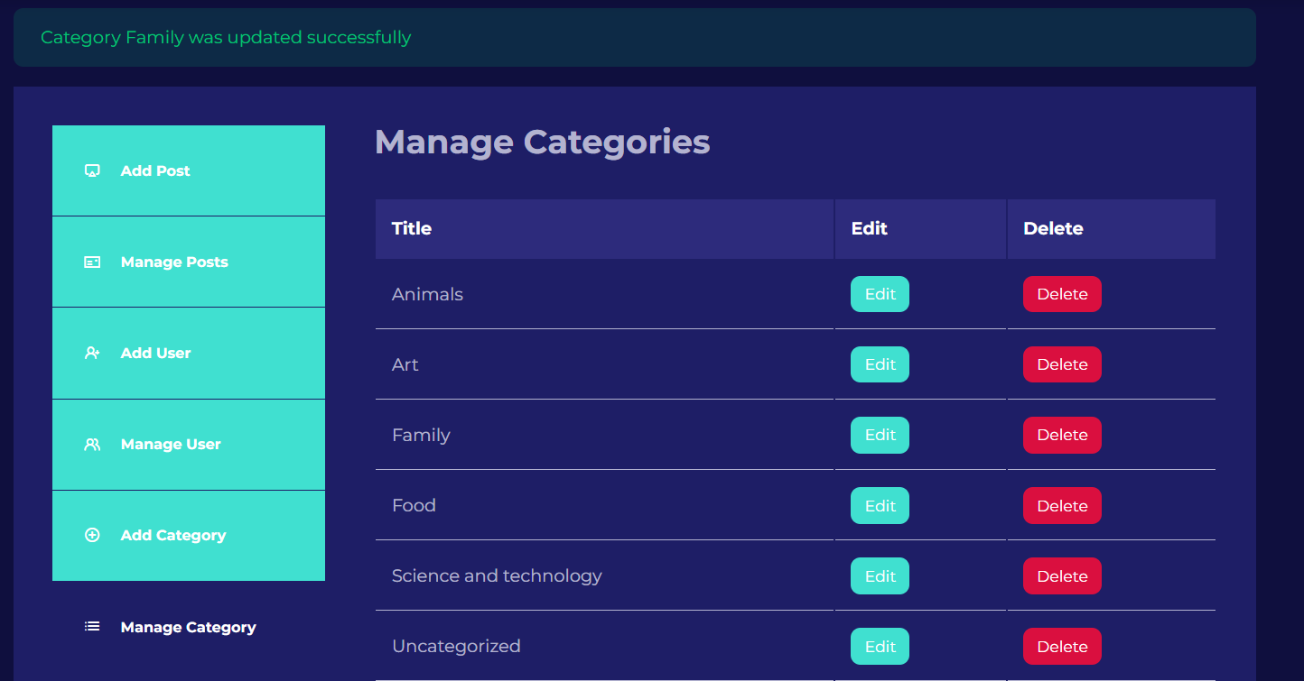

As shown in the snap that family category has been updated.

##### Delete Category

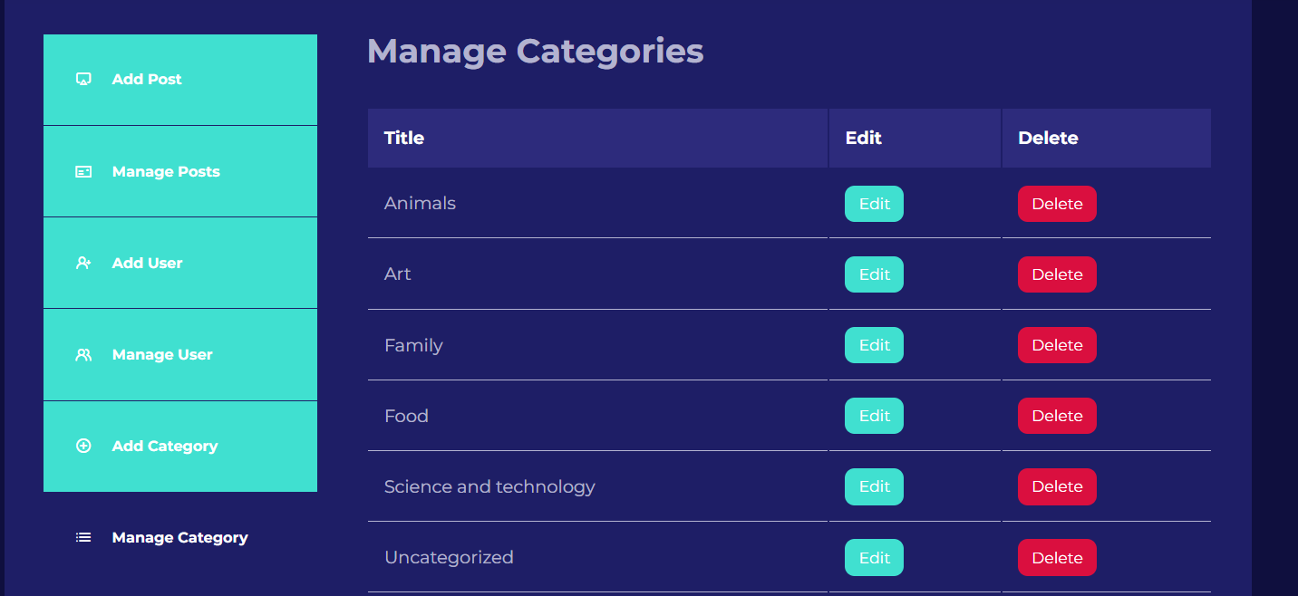

Admin can delete the category by just simply deleting the red button.

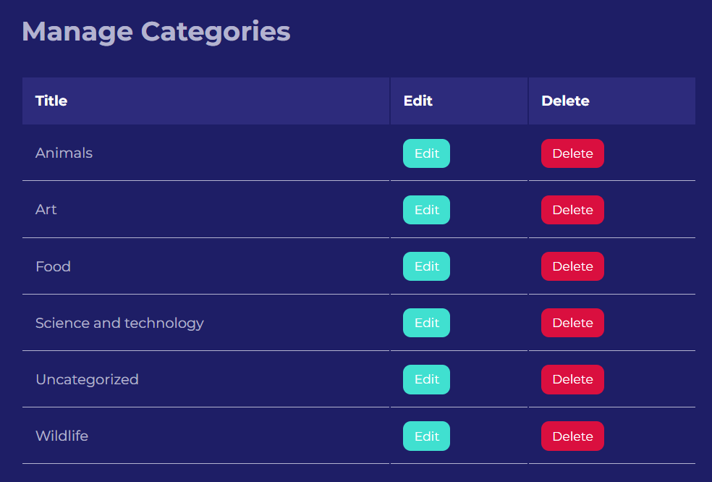

Admin can delete the category from this snap.

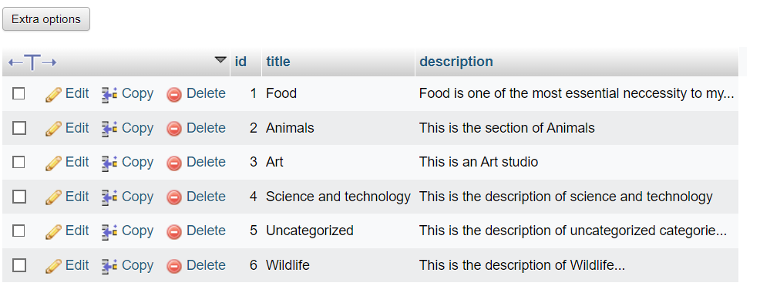

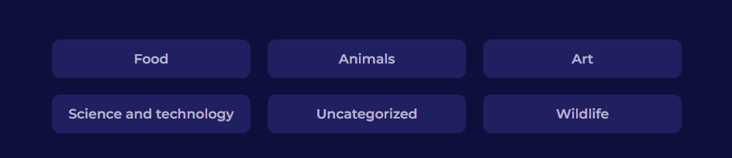

## User Manual

User’s Profile

Web Page Art Gallery to view Art

UI/UX Motion Art to Experience

Blog Page contains of Users, Categories and Post Information

Name of website &Main Page of Web Information Post

### User /Admin/Visitor Interface

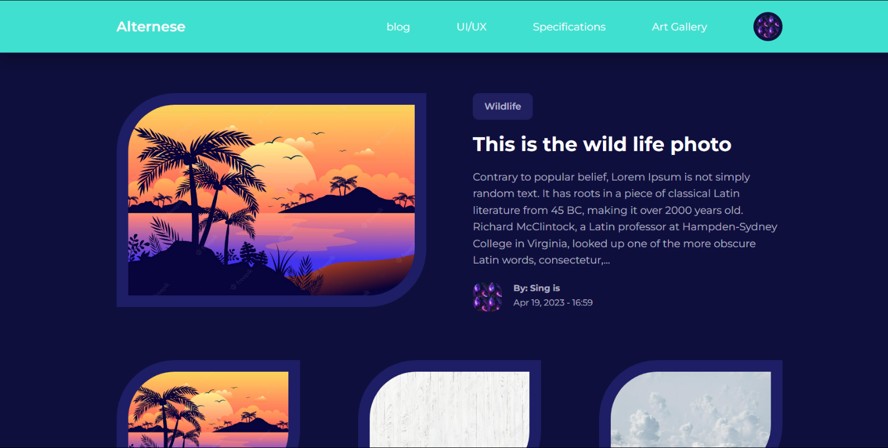

Featured Post of this Website

The Category of uploaded post

The Title and the body of the post

Other Post not Featured

The author of uploaded post

User’s Profile

Web Page Art Gallery to view Art

UI/UX Motion Art to Experience

Blog Page contains of Users, Categories and Post Information

Name of website &Main Page of Web Information Post

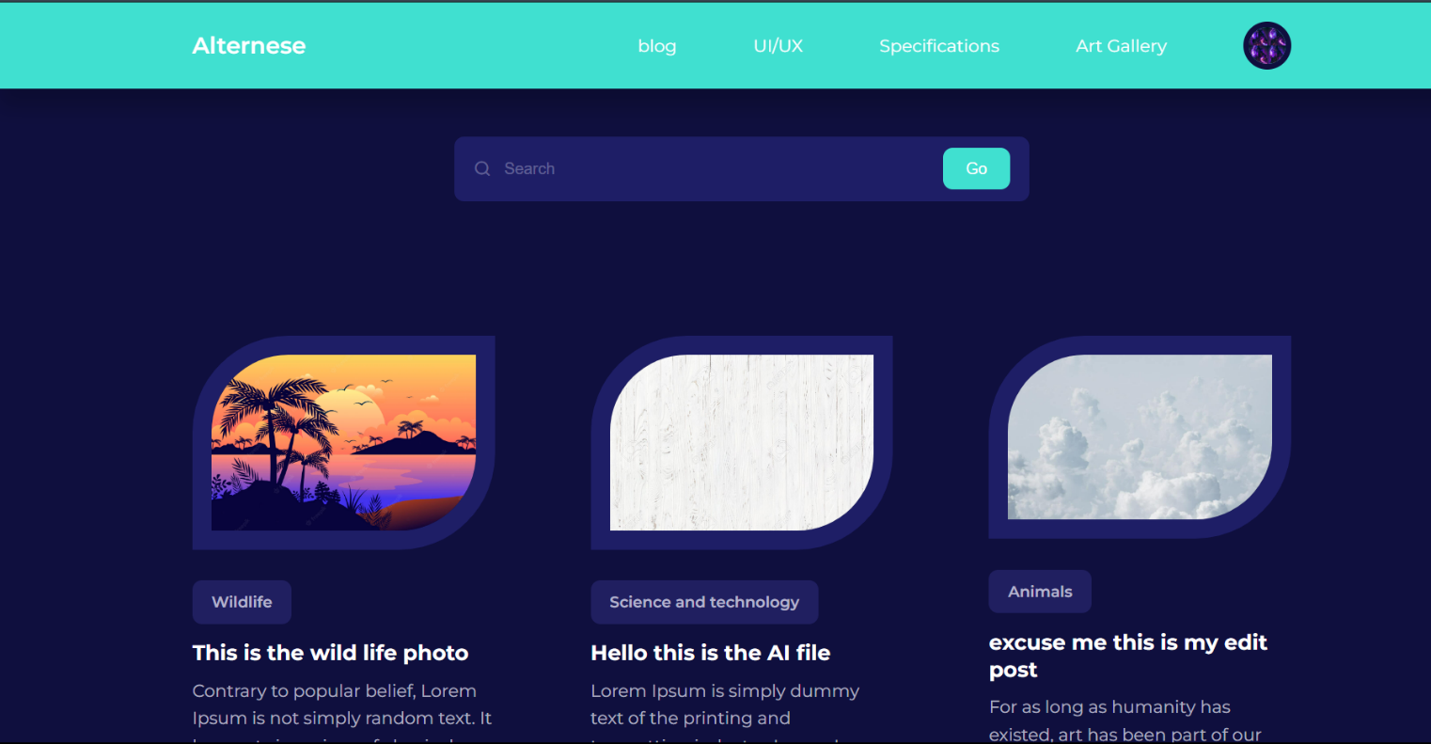

The Go button is to find the word contain in the post

The search bar is used for the visitor/user to search the post easily

Other post uploaded by the users.

Web Page Art Gallery to view Art

UI/UX Motion Art to Experience

Blog Page contains of Users, Categories and Post Information

Name of website &Main Page of Web Information Post

User’s Profile

Solar System revolving art

Blue ring shade fading art

Closing and opening heart art

Butterfly art

Stick balling art

Rectangle roll

Sign fading art

Ring rotational art



Cyan cube rotating

Ball climbing stairs art

Green Ball bouncing between ring art

Big cube freely moving art

Ocean waving art

Blue and white shade ball rolling

Red bouncing ball



Saturn 360

Dancing sphere

One stick ninja art

White splash art

Black ninja art

Cylinder sea saw ball art

Solar shade art

Mini square shade

Colorful Beyblade art

Rainbow circular art

Wi-Fi Searcher art



Drawing and removing by pencil

Knife firing art

Planet moving art



Bouncing/dancing spring

Spaceship art

System art

Prism moving gently art

Tube changing color art

### Sign up page (user manual)

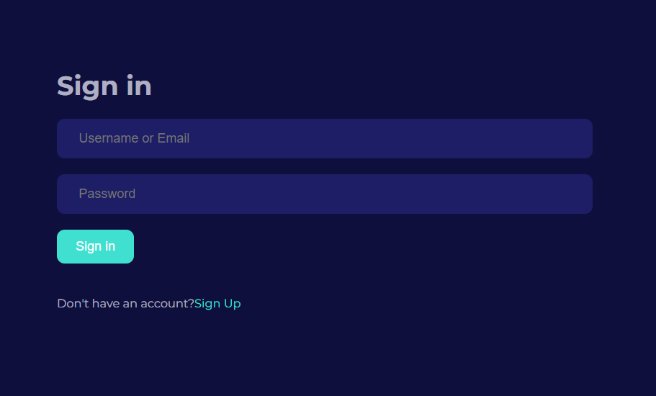

User or Admin have to enter the high security password to sign in

User or admin have to sign in through entering email of username

After the User / Admin is eligible the user can sign in easily

### Sign up page (user manual)

To become a user of this webpage, Enter the First Name

Username is required to sign in back for the users

Email requirement is necessary for the update of news and posts

After the User / Admin is eligible the user can sign in easily

Confirmation password is need for the new user to become the part of this webpage

New User must enter the password for the privacy issues.

To become a user of you need to fill the last name

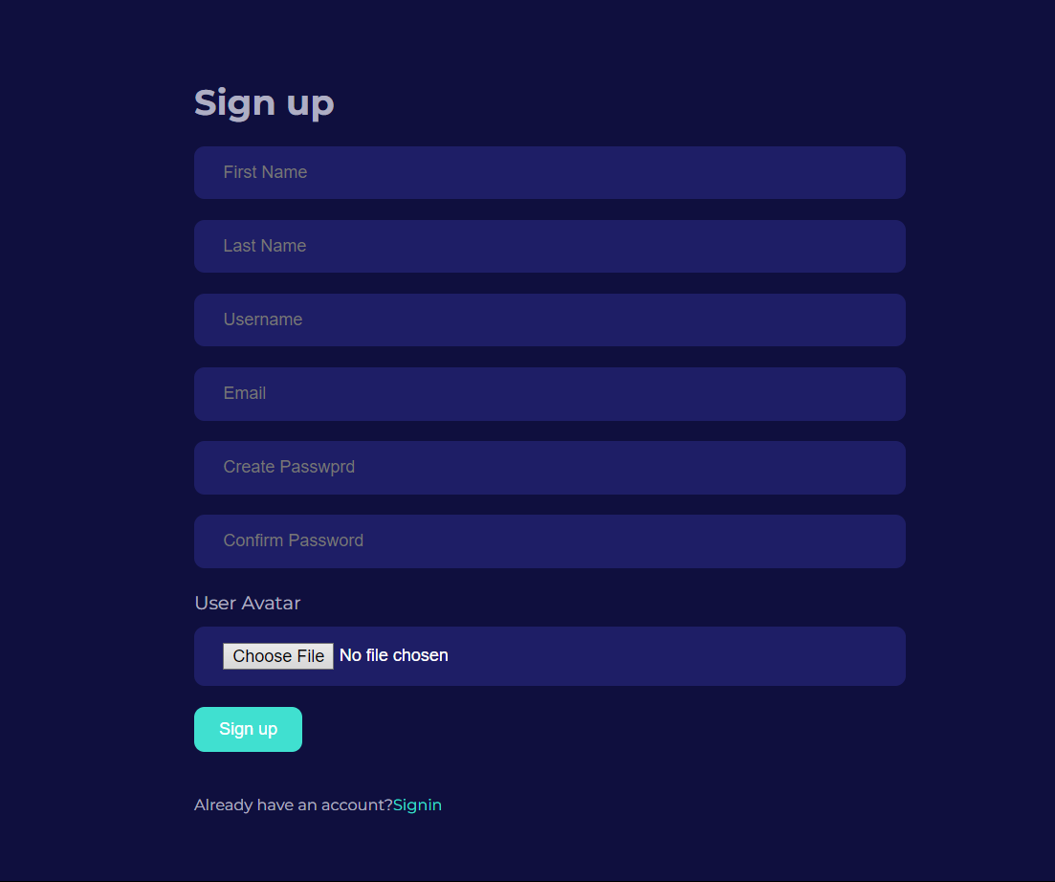

After the all the required information by the system the new user can click signup to be part of the system

## Admin Manual

Admin can edit post in the edit post page by clicking this

Admin can Delete the post easily through this button

### Manage Post

Admin can add different category through this section

This is Admin Add Post Section to Add Post

Admin can manage the post through this section

Admin can manage user through this section

Admin can add new user through this section

Admin can Manage Different Category through this section

### Add Post

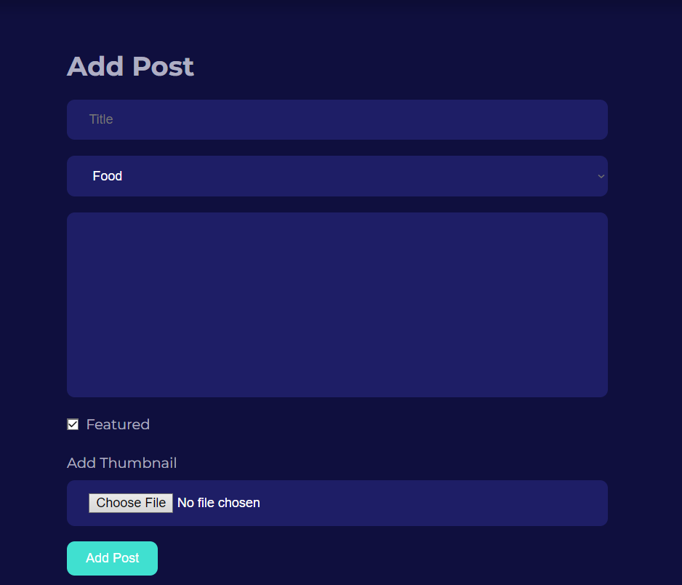

Admin can fill the title of the post

Admin can select the category by drop down menu

Admin can choose file from the device such as laptop or PC

Admin has to fill the information of the title for the post content

Admin can feature post through this

Admin Can Add Post after filling required information given above

### Edit Post

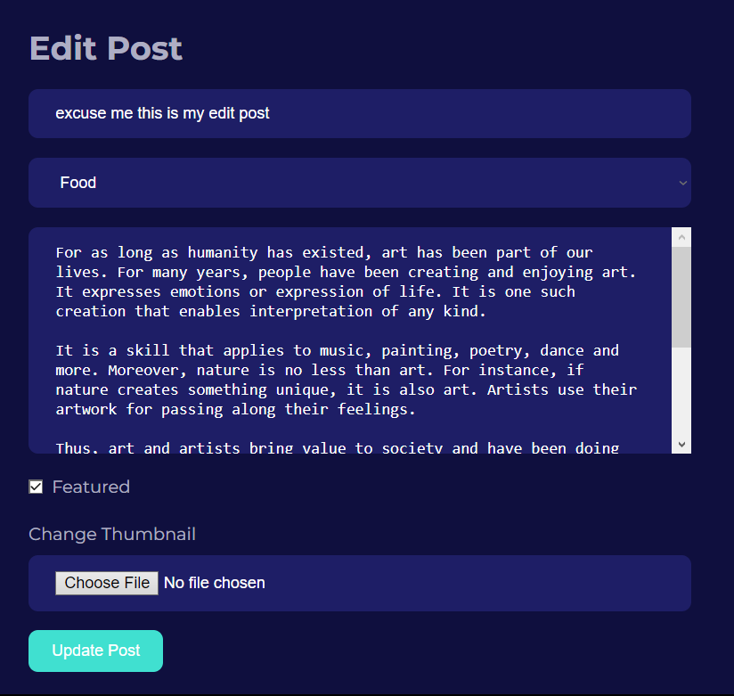

Admin can fill the title of the post

Admin can select the category by drop down menu

Admin can choose file from the device such as laptop or PC

Admin has to fill the information of the title for the post content

Admin can feature post through this

Admin Can Add Post after filling required information given above

### Add User

To add a new user of this webpage, Enter the First Name

Last name has to be filled for the new user registration

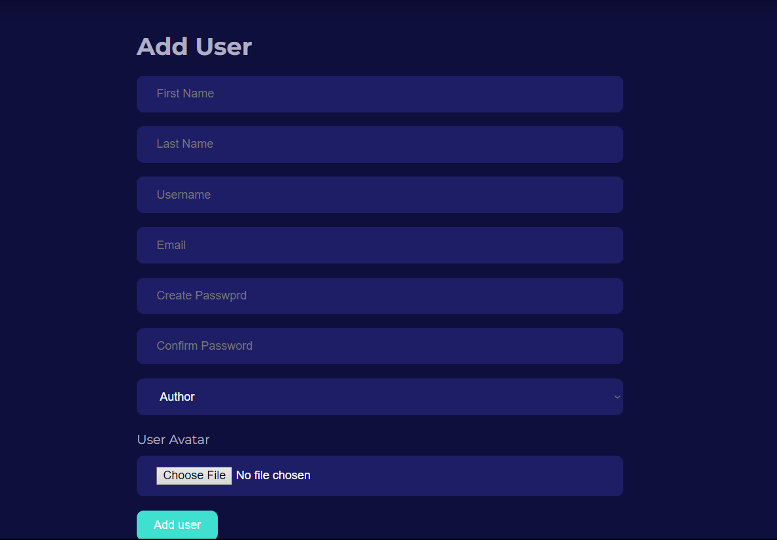

Confirmation password is need for new user to become the part of this webpage

Username is required for registration to sign in back for the users

To Add user Admin must enter the password for the privacy issues.

Email requirement is necessary for the update of news and posts

After the User / Admin is eligible the user can sign in easily

### Edit User

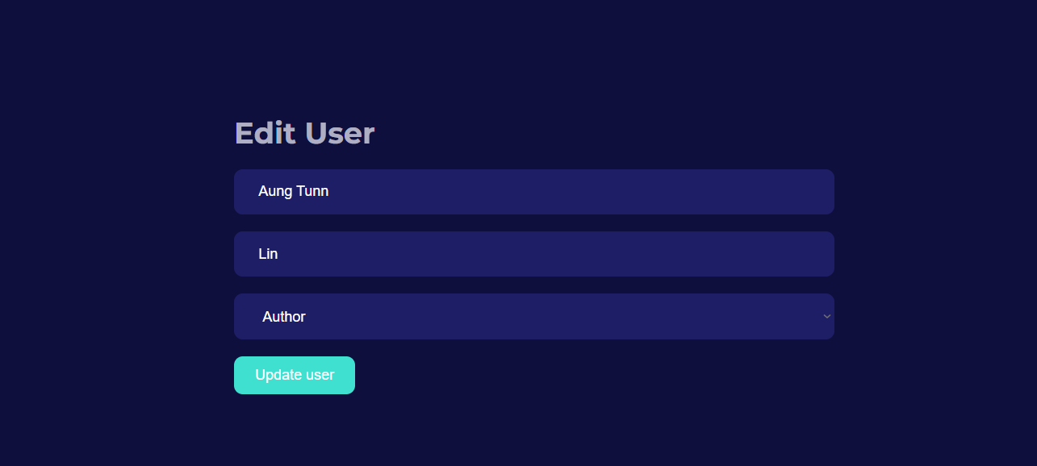

Last Name is need to Edit the user

Admin Can Update the User after fulfilling the requirements on above.

First name is also need to Edit user

Admin has right to change the Authority of the user and the admin

### Delete User

Admin can go to Edit Page by clicking the edit button

To Delete the user the admin has to just click the delete button to delete the user

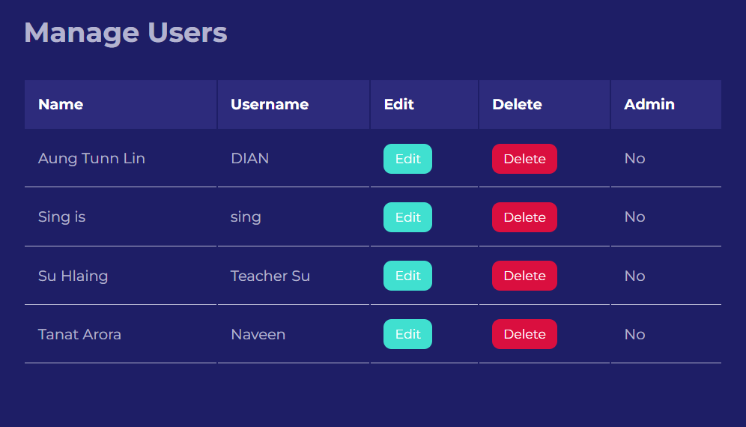

The Data Information of the user

### Add Category

### 

### 

Admin can Add Category of the Title for the post

Admin have to write the Description related on the topic of Category

Admin can Add easily to Add category after filling the correct form.

### Edit Category

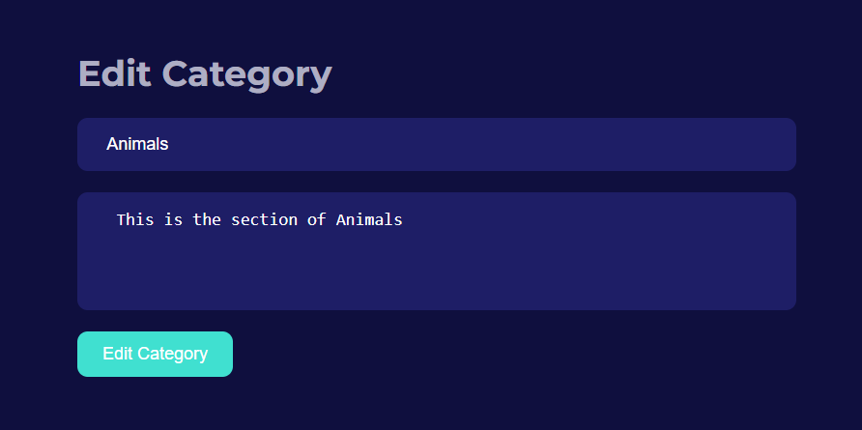

Admin have to edit the Description related on the topic of Category

Admin can Edit easily to Edit category after filling the correct form.

Admin can delete the Category Title just by clicking the Delete Button

Admin can go to Edit Category Page by clicking the Edit Button

### Delete Category

The Title of the Category Post

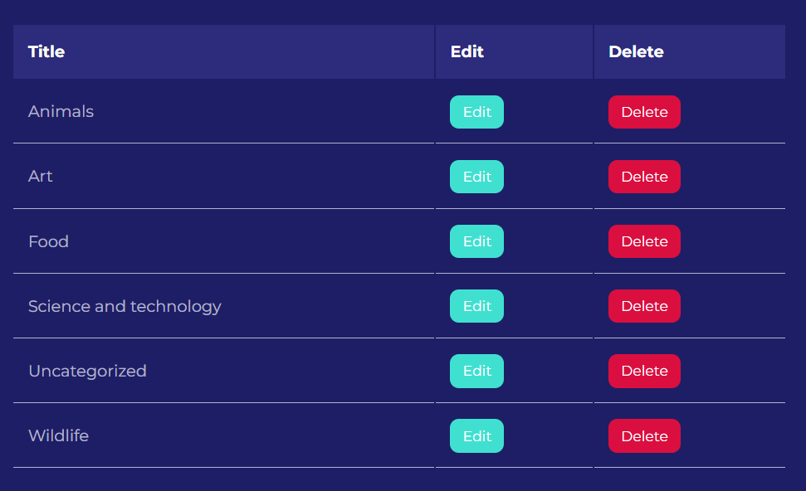

## **Section E**

### Limitation of the system

Although there are numerous functional and non-functional elements in our hospital administration system, we have also noted a few restrictions. One of these restrictions is that, at the moment, uploading images to the system involves manual data entry because drag and drop capability is not supported by the system. Additionally, while if users may buy drugs through the system, the only accessible payment option is cash, which may not be practical for all users.

We are always trying to make the system better by fixing these problems because we understand that these restrictions may negatively affect user experience. Our team is looking into possible alternatives to speed up the photo upload procedure and increase the payment choices for purchasing medications. To increase overall functionality and user happiness, it's critical to recognize constraints in software systems and strive to fix them.

### Recommended changes

In addition, we'll employ data analytics to learn more about user behavior and use trends, which will help us spot areas that might require more changes and additions. To create a smooth user experience and enhance the overall functioning of the application, we will also link the system with other healthcare platforms.

We'll go through rigorous testing and quality assurance procedures to make sure these new features and upgrades live up to the demands and expectations of our users. To make sure the application satisfies the demands of its intended users, this will comprise both human and automated testing as well as user acceptability testing. To give our users with the greatest experience possible, we are dedicated to constantly enhancing and developing our application.

### Critical reflection of the project experience

One of the most challenging aspects of this project has been the implementation of coding, which has presented me with a number of obstacles to overcome. However, through hard work and dedication, I have been able to gain a deeper understanding of the coding process and have successfully implemented various functionalities into the system.

Through this project, I have learned about various concepts and ideas related to these fields. I have gained valuable insight into the process of designing and implementing a system, including the importance of budget management and allocation of responsibilities to each stakeholder involved in the project. Additionally, I have been introduced to advanced techniques for data collection, which I believe will be immensely helpful in my future work.

### 1.2Changeover Procedure (System Implementation)

The typical switching method phases might be as follows:

**Planning and preparation:** Create a thorough implementation plan that identifies the duties, available materials, and timetable for the transition process. Coordination with the development team, stakeholders, and users is part of this.

**Migration of data:** Move the pertinent information from the old system to the new web application. This might entail converting data formats, mapping data fields, and maintaining data integrity during the transfer process.

**Testing and quality assurance:** To make sure the new web application works as intended and satisfies the criteria, thoroughly test it. This involves doing usability, security, compatibility, and bug testing.

**User training and documentation:** Educate users of the web application on the new features, capabilities, and processes by offering training and support. Create documentation, user manuals, and instructions to help users get the most of the system.

**Depending on the complexity and size of the web application,** you may decide to build the system either concurrently with the current system for a period of time or in stages, introducing users to the new application gradually.

**Go-live and transition:** After the new web application has been given the all-clear to go into production, launch it and make sure there is a seamless changeover from the previous system to the new one. During the early phase, keep a tight eye on the system to handle any potential problems.